# GLKLN V1.0

|  |  |
| --- | --- |
| **Description** | GLKLN V1.0. |
| **License** | [CC-BY-SA](https://creativecommons.org/licenses/by-sa/4.0/deed.en) |
| **Author** | Konstantin Gulitski |
| **Contributors** | NA |
| **Based-on** | NA |
| **Categories** | NA |
| **CAD Models** | [GitHub](https://github.com/Konstg16/GLKLN-V1.0) |
| **External Link** | [GitHub](https://github.com/Konstg16/GLKLN-V1.0) |

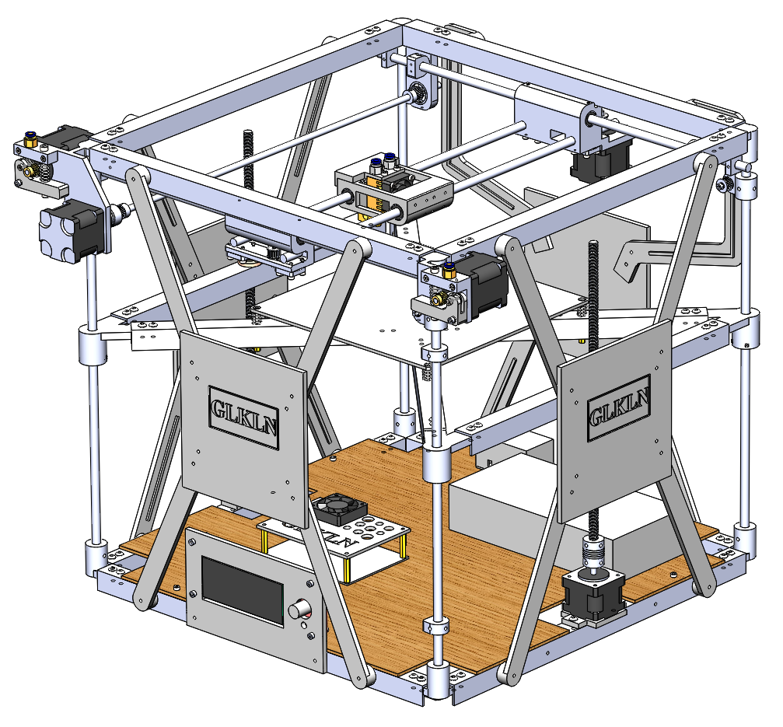

# License

This work is licensed under the Creative Commons Attribution-ShareAlike 4.0 International License. To view a copy of this license, visit http://creativecommons.org/licenses/by-sa/4.0/ or send a letter to Creative Commons, PO Box 1866, Mountain View, CA 94042, USA.

# Specification

|  |  |
| --- | --- |
|  |  |
| Working volume (max) | 240mm (X) x 290mm (Y) x 310mm (Z) |
| Working volume (nominal) | 220mm (X) x 220mm (Y) x 210mm (Z) |
| Working materials | PLA, ABS, others |
| Nominal Speed | 120mm/sec |
| Max Speed | 200 mm/s (depending on the object to be printed) |
| Filament | 1.75mm |
| Configuration | XYZ Cartesian drive using stepper motors |
| Computer interface | USB |
| Layer thickness | Adjustable 0.1mm, 0.2mm, 0.3mm, 0.4mm |
| Material handling | Two fixed material deposition extruders |
| Hotend nozzle size | 0.1mm, 0.2mm, 0.3mm, 0.4mm |
| Positioning accuracy | XY 0.1 mm |
| Motherboard | Makerbase MKS Gen L V1.0 |
| Power supply | 25A/12V DC, 300W |
| Firmware | Marlin |
| Host SW | Repetier-Host |
| Exterior dimensions | 528 mm wide x 541 mm deep x 433 mm high |
| Weight | about 18 Kg |
| Cost | < $300 (USD) |

# Main features/Improvements

1. Cubic construction – Strong and Stable
   * The cubic construction is still to be the most strong construction that provides the best quality at the cheaper cost.
2. Simple construction – The hotbed Z-axes are the part of the construction
   * Four vertical cornels of cubic construction are the Z-axes of the hotbed. It decreases the number of parts and cost.
3. The Hotbed can be increased – up to 240mm x 290mm
   * The nominal hotbed is 220mm x 220mm. You can upgrade up to 240mm x 290mm.
4. The Z-axis can be increased – up to 310mm
   * The nominal Z-axis has a 310 mm length. You can upgrade up to 350mm
5. The belt connection is simple and confident.
6. Almost all parts of construction made of plastic.

# Development

This is the first version that represents the nominal configuration. Several parts planned to be developed such as a cable holder, filament roller holders, ventilation system for hotends.

# History

This is the first version of this kind 3D printer.

# Bill of Materials (BOM)

The updated version of the BOM can be downloaded from the project repository on the [GitHub](https://github.com/Konstg16/GLKLN-V1.0).

# Printed parts

All parts can be printed with 60% filling and 0.2 mm layer theekness.

Corner LU – Front Left Upper Corner: 1 pcs

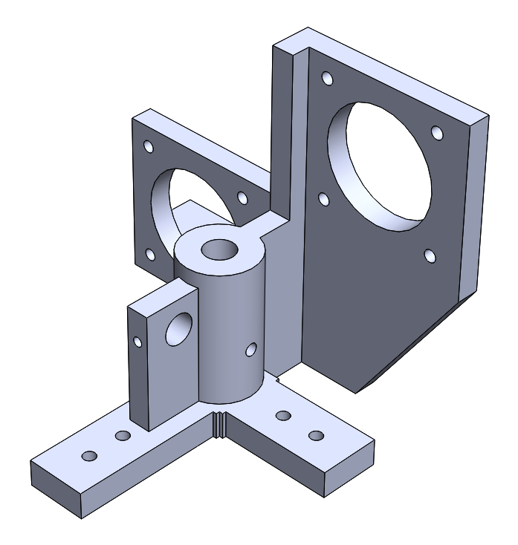

Corner LU B – Back Left Upper Corner – 1 pcs.

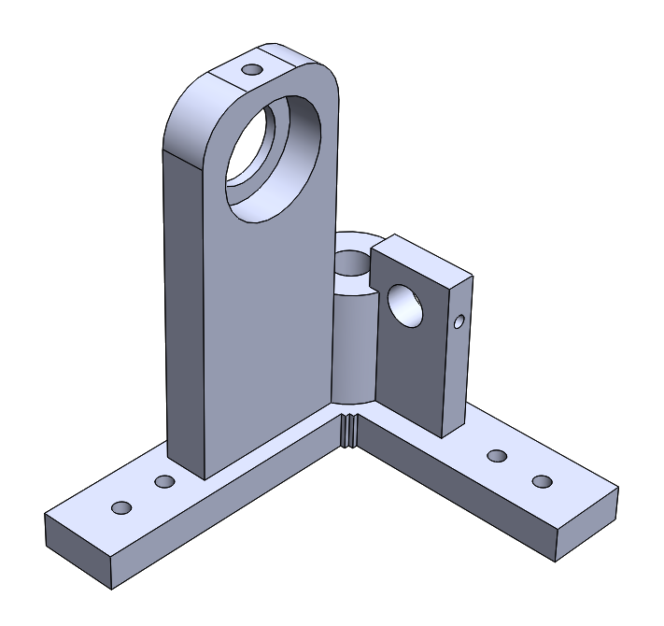

Corner RU F – Front Right Upper Corner: 1 pcs.

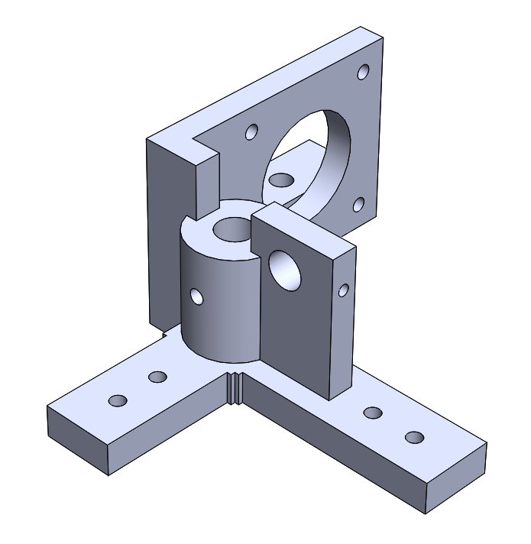

Corner RU B – Back Right Upper Corner: 1 pcs.

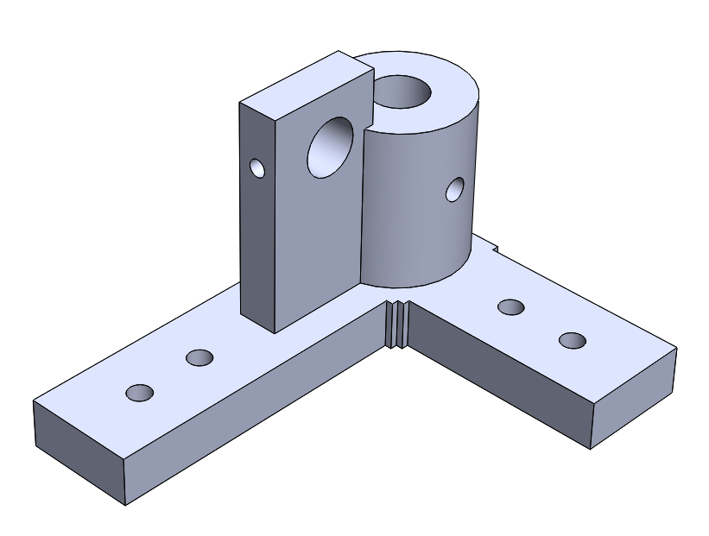

Corner L – Lower Corner: 4 pcs.

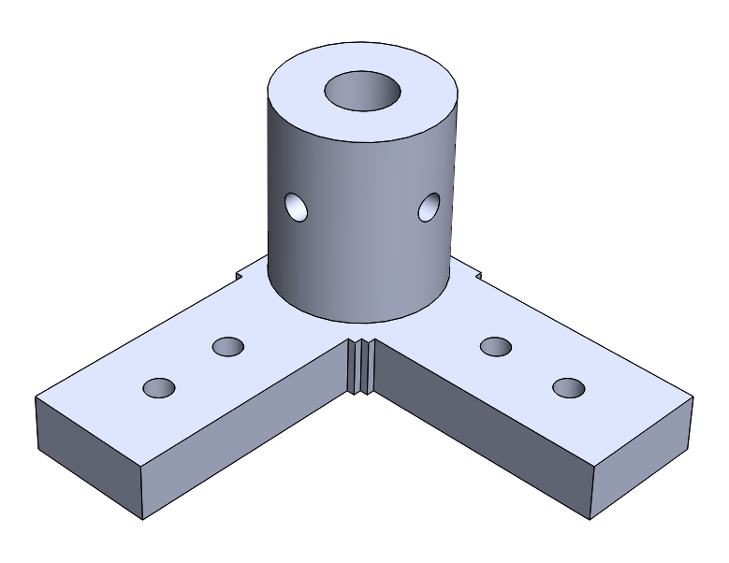

Corner B1 – Corners of the hotbed: 4 pcs.

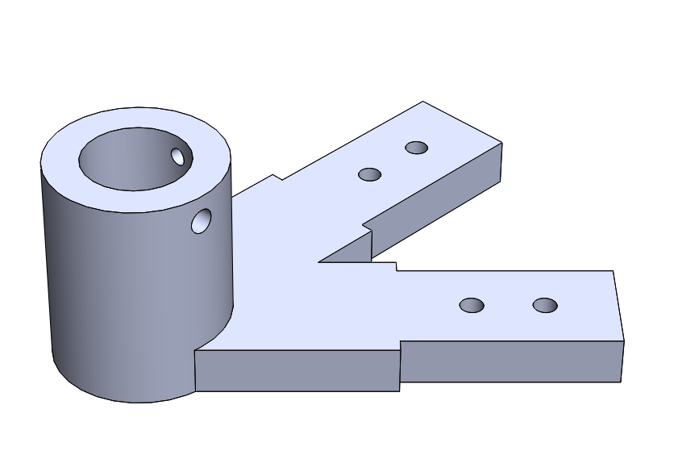

Cross – Hotbed cross 1 pcs.

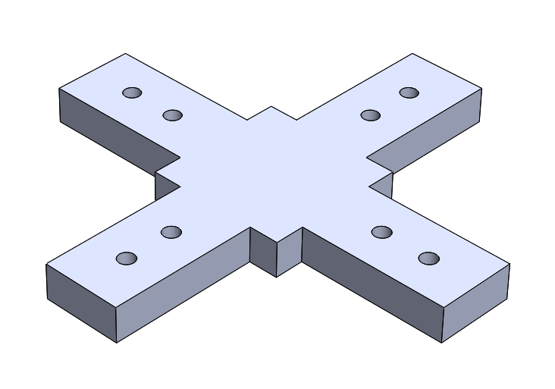

Wheel holder: The holder for X-axis timing wheels, 2pcs.

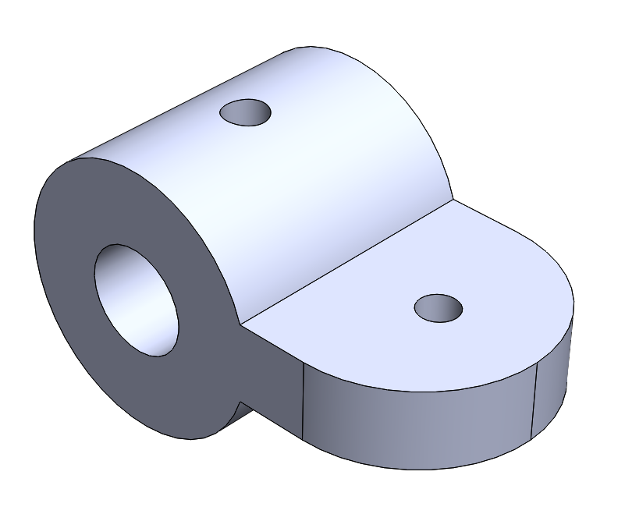

Motor Holder 1: The holder for Z-axis motors, 2pcs.

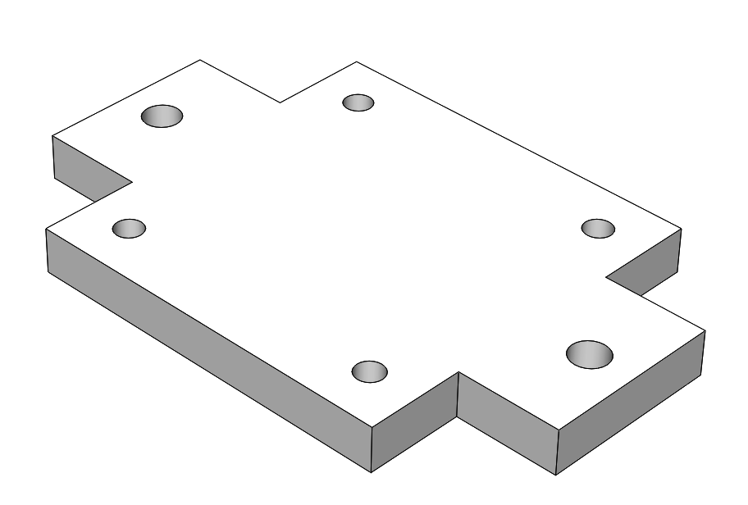

Front panel: The panel for Screen 2004, 1pcs.

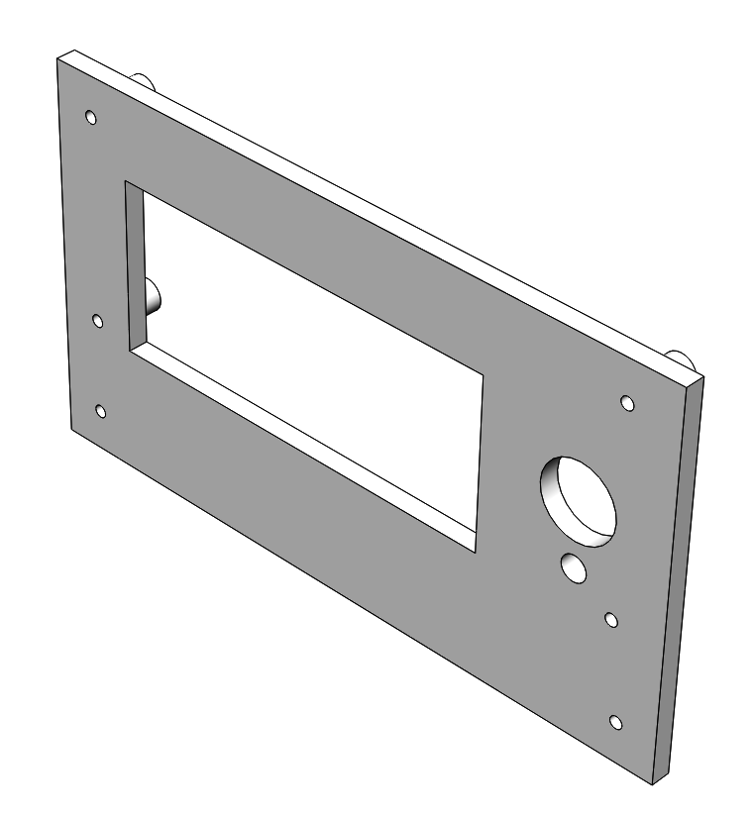

Front Train: The front carriage, 1pcs

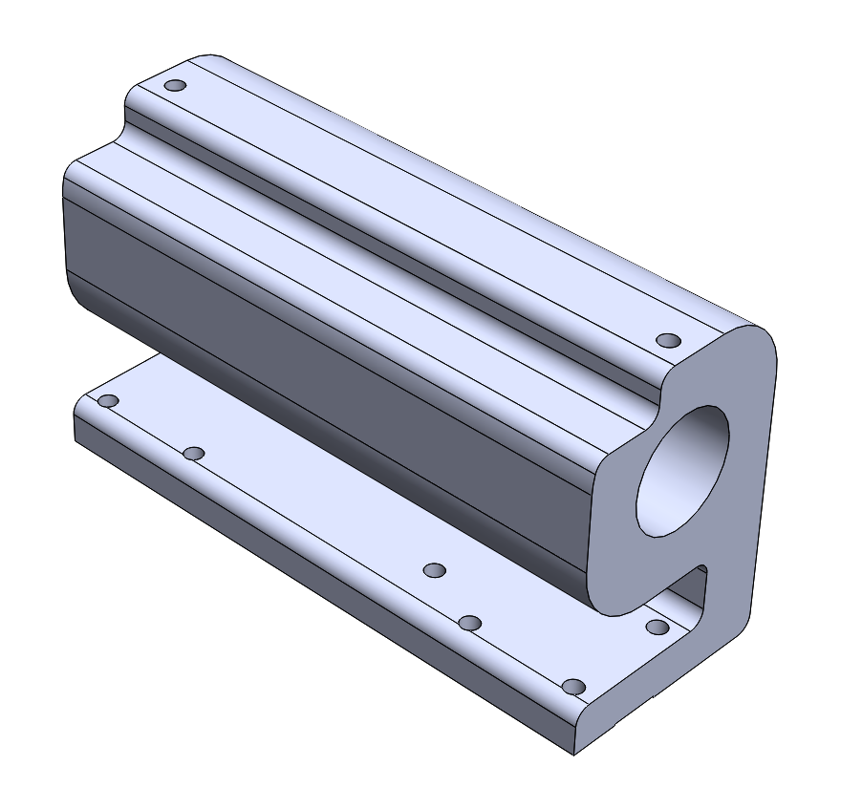

Extruder Flap: 1pcs

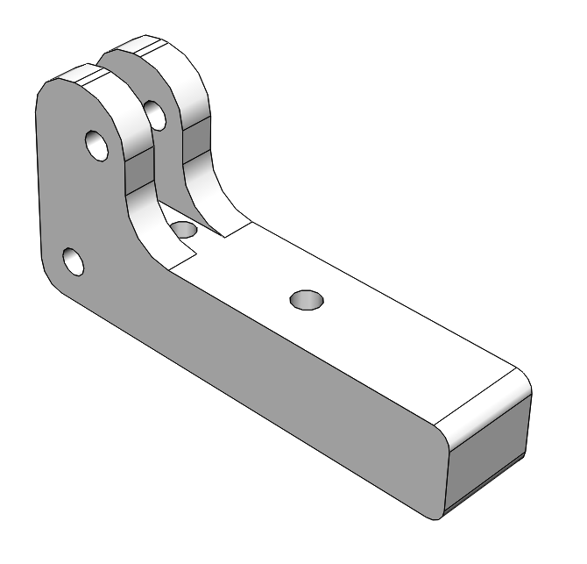

Cap MkB: The upper panel over MKB, 1pcs.

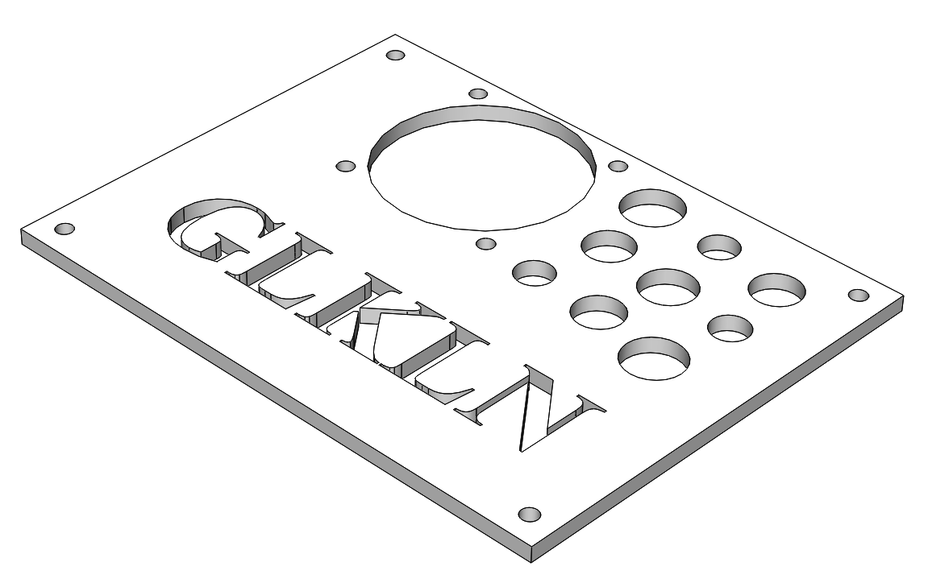

Back Train: The back carriage, 1pcs

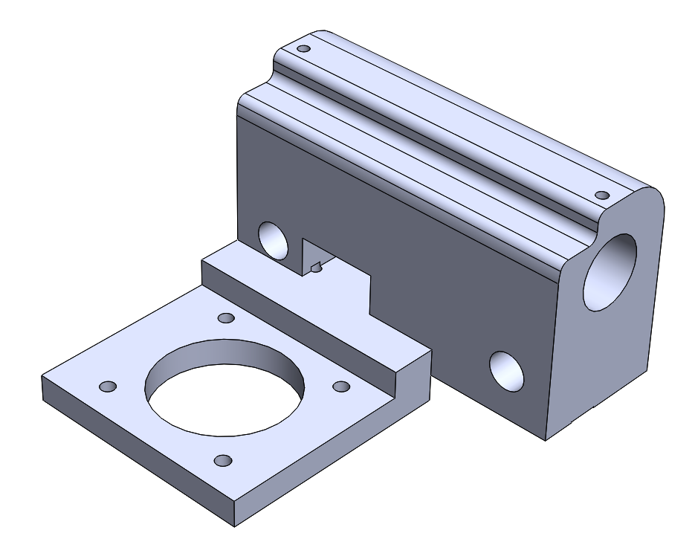

Y Train body: The carriage, 1pcs

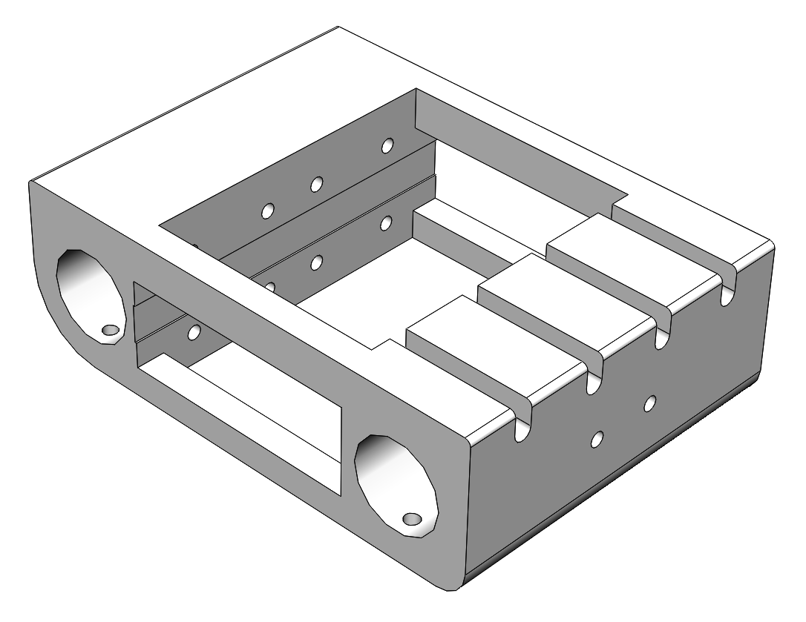

End Stop holder: 6pcs if you want to use two end-stop switches for each axis.

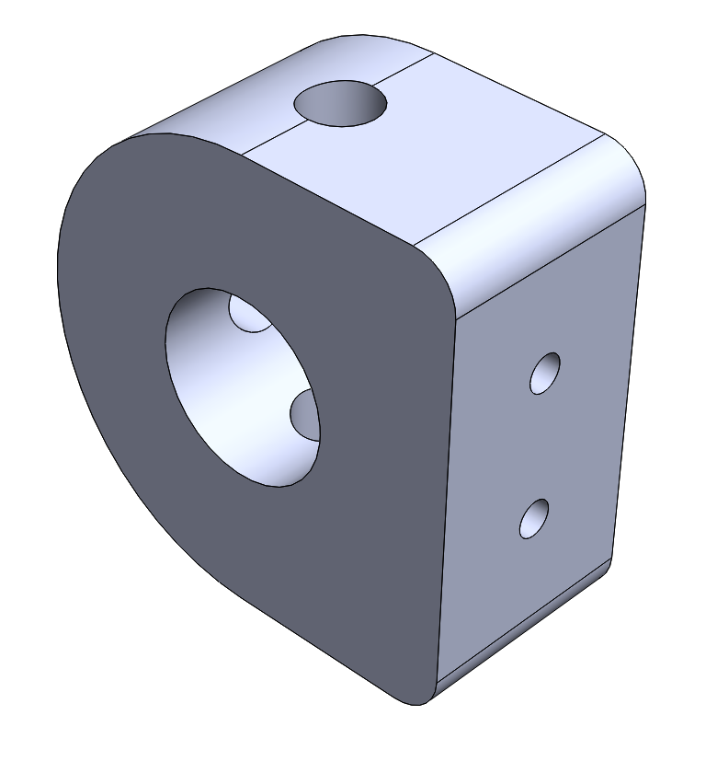

Timing belt holder: The holder required for fixing the timing belt end. 6pcs

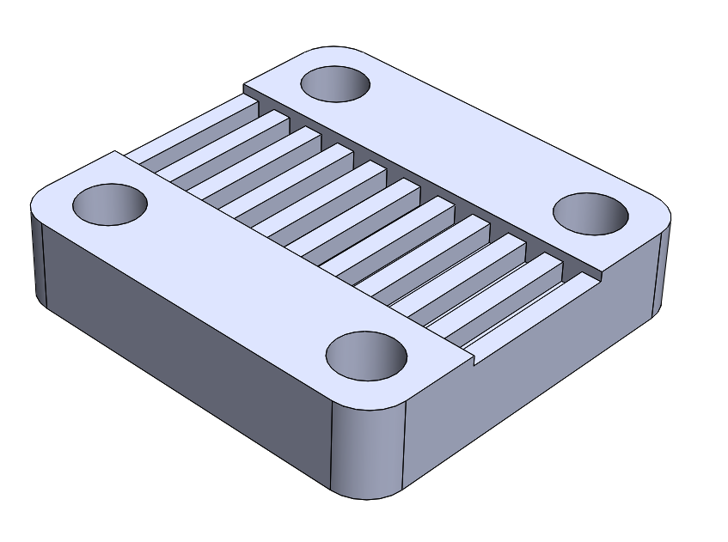

Base plate: finally produced from Fiberboard

Side panel: The panel for all four sides of the printer, 4pcs

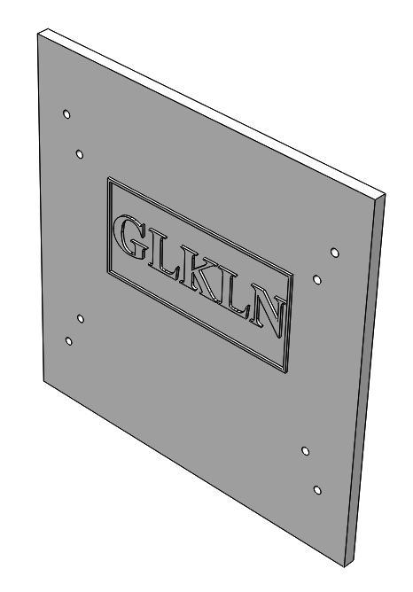

Side panel lead: The connector between the side panel and the profiles of upper and lower frames. 14pcs

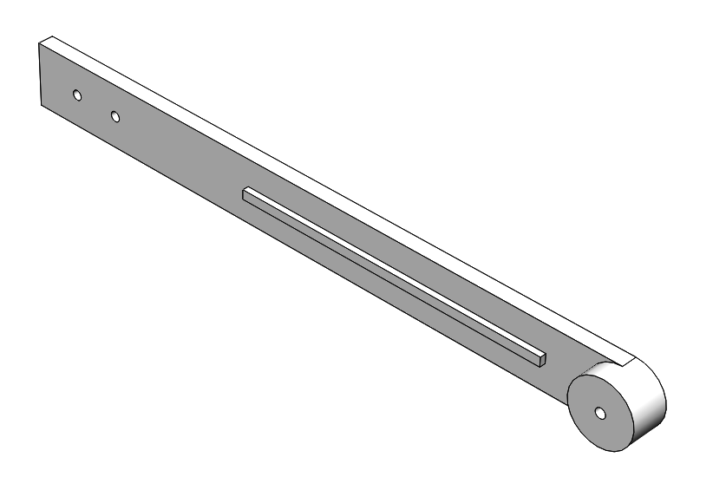 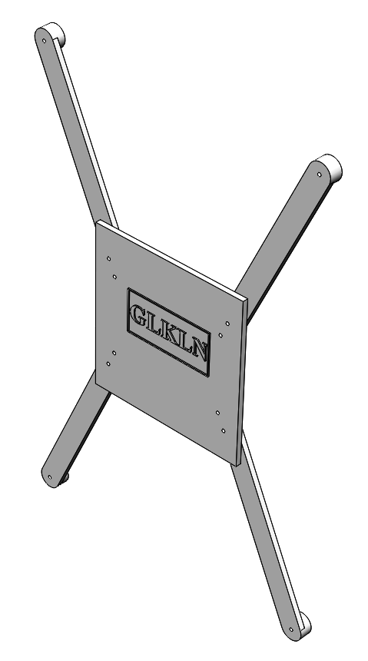

Side panel lead L: The connector between the backside panel and the upper frame profile at left. 1pcs

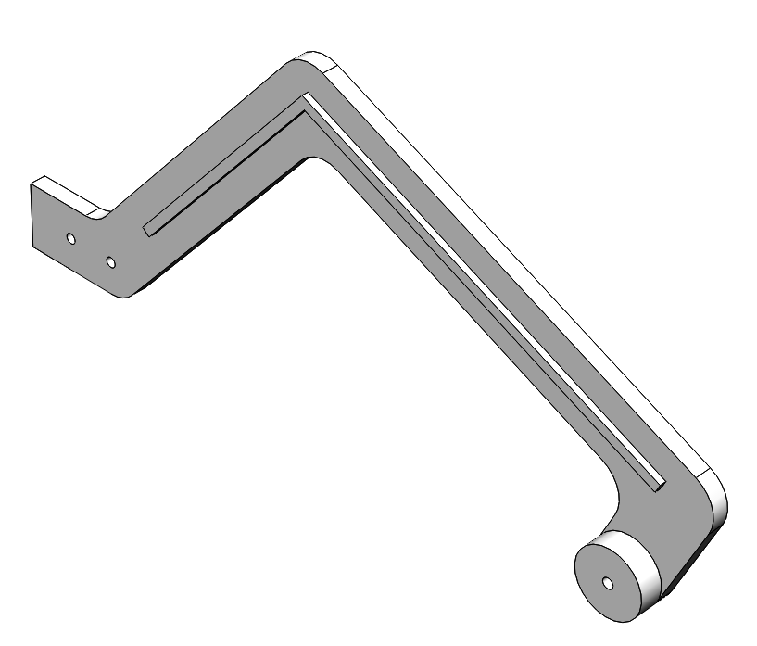

Side panel lead R: The connector between the backside panel and the upper frame profile at right. 1pcs

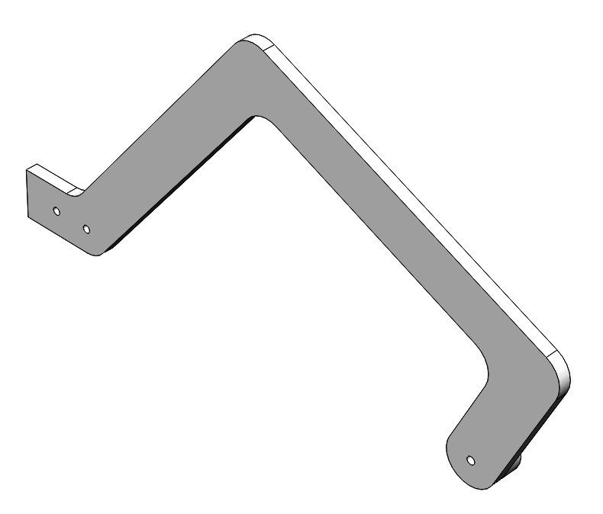 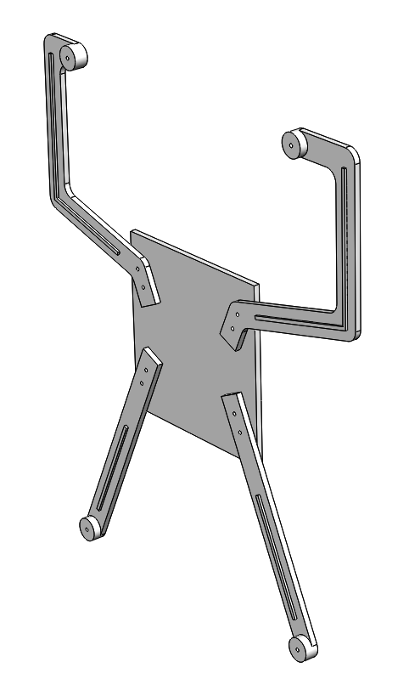

Power Supply Holder: The holder for power supply cable connector with fuse, 1pcs

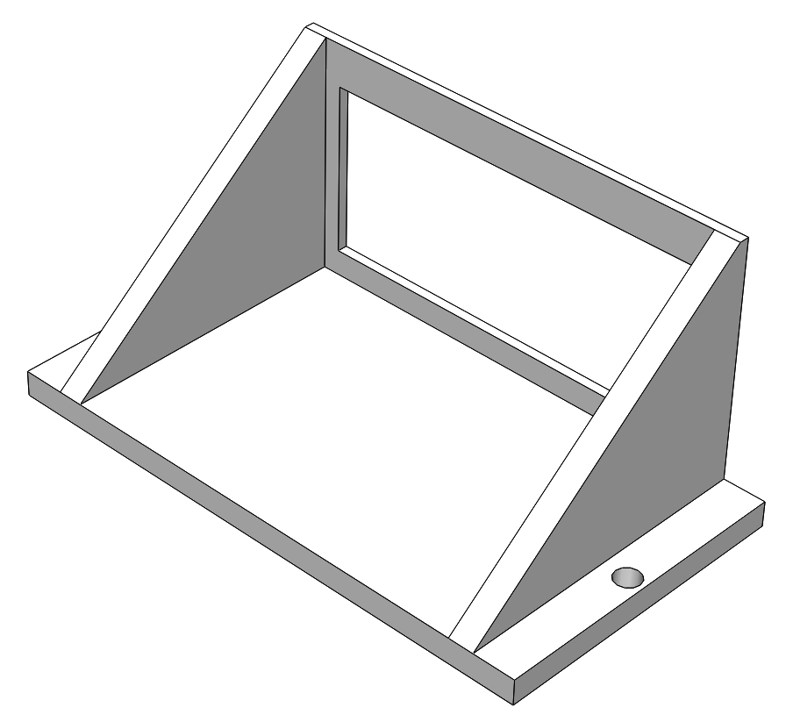

Power Supply Holder Cap: The cap of the holder for power supply cable connector with fuse, 1pcs

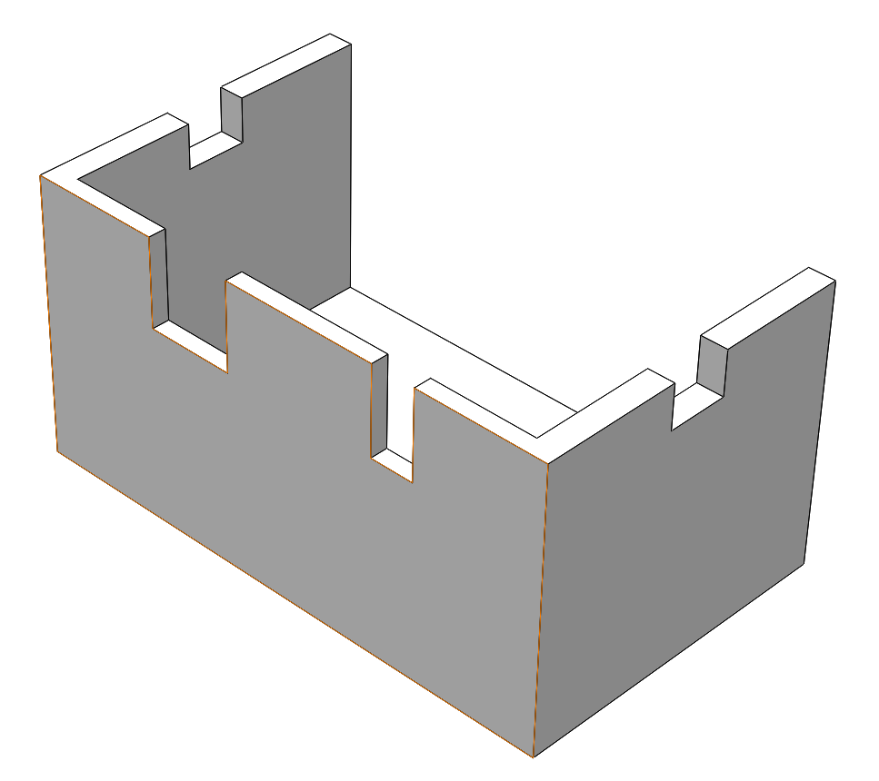

Extruder Holder: 1pcs

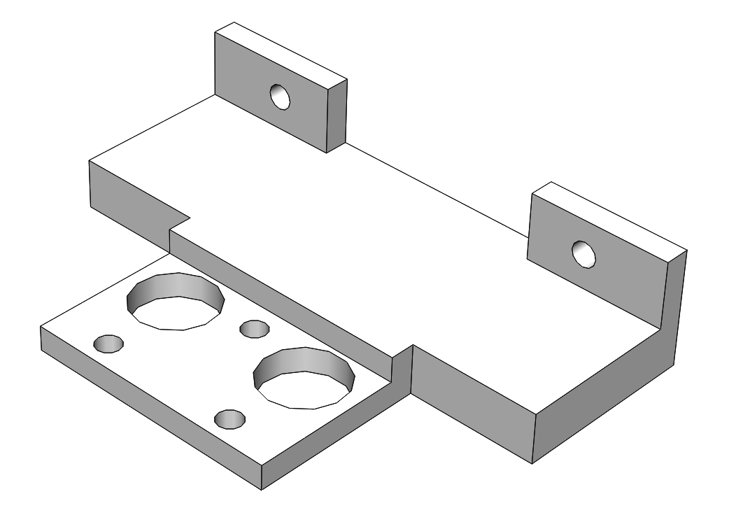

# Electronics

The printer is based on the [MKS-GEN L](https://github.com/makerbase-mks/MKS-GEN_L) motherboard.

# Software

The software is [Marlin-bugfix-1.1.x](http://marlinfw.org/) adjusted to the printer design. The updated SW version can be downloaded from the project repository on the [GitHub](https://github.com/Konstg16/GLKLN-V1.0).

# Order things to do

1. Check if you have all the required tools;
2. Assembly the low frame;
3. Assembly the upper frame;
4. Assembly the sliding hotbed frame;
5. Connect the low frame, upper frame and sliding hotbed frame;

# Assembly sequence

# Tools required for the mechanical assembly mechanical

# Equipment needed for the electrical wiring

# Low Frame

1. Take four pcs of Corner L and make thread M4 in four holes of each corner.
2. Make two pcs of U-profile in accordance with below drawing for the left and the right sides

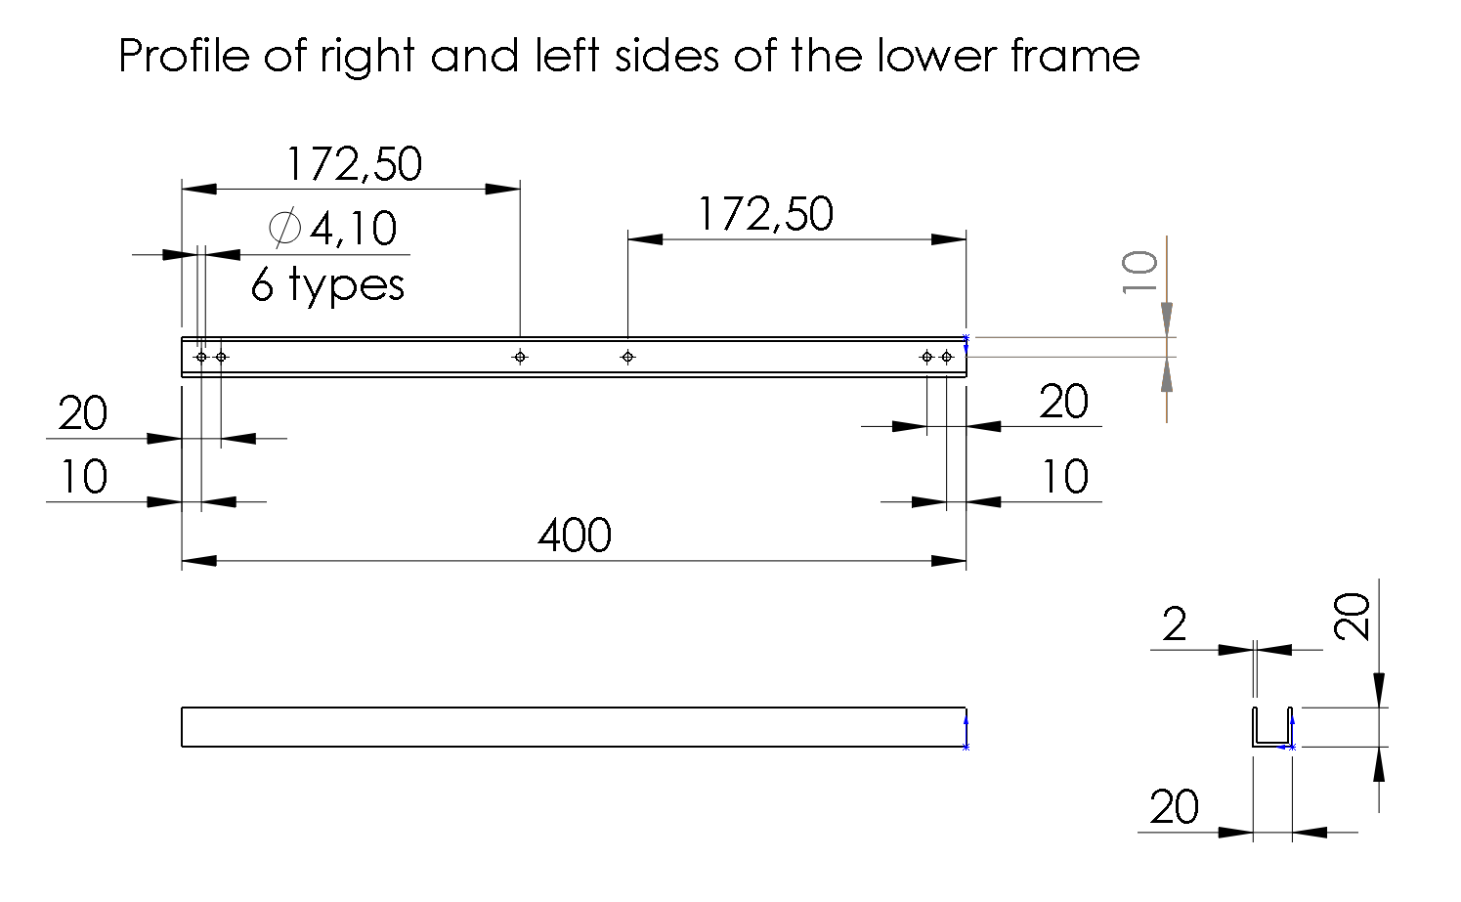

1. Make three pcs of U-profile in accordance with the below drawing. Two pcs will be used for the front and the back sides of the low frame and the one will be required for the front of the upper frame.

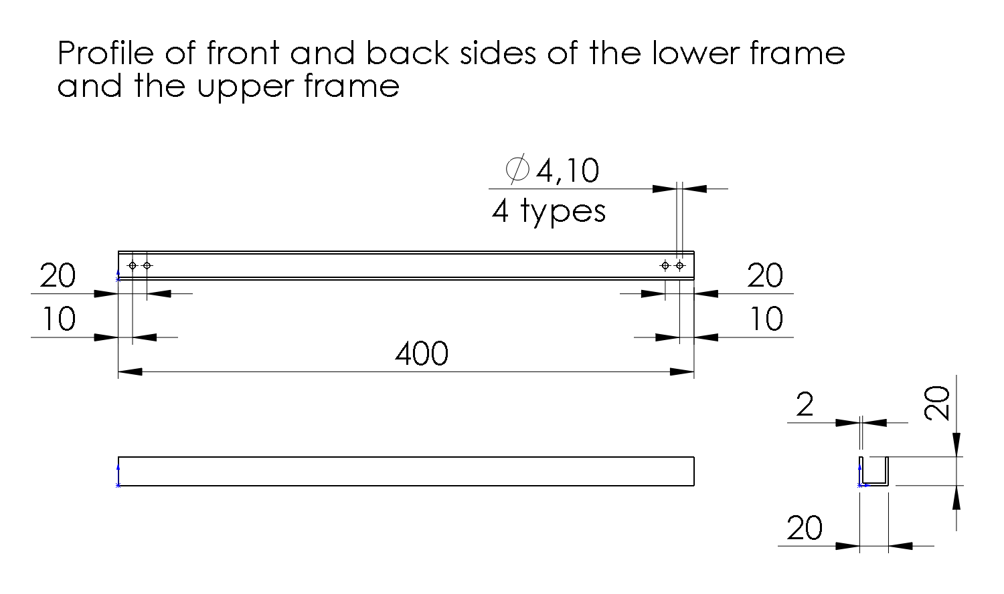

1. Assembly the low frame as it is shown on the picture below by using socket button head screws M4x12 and M4 nuts from the bottom.

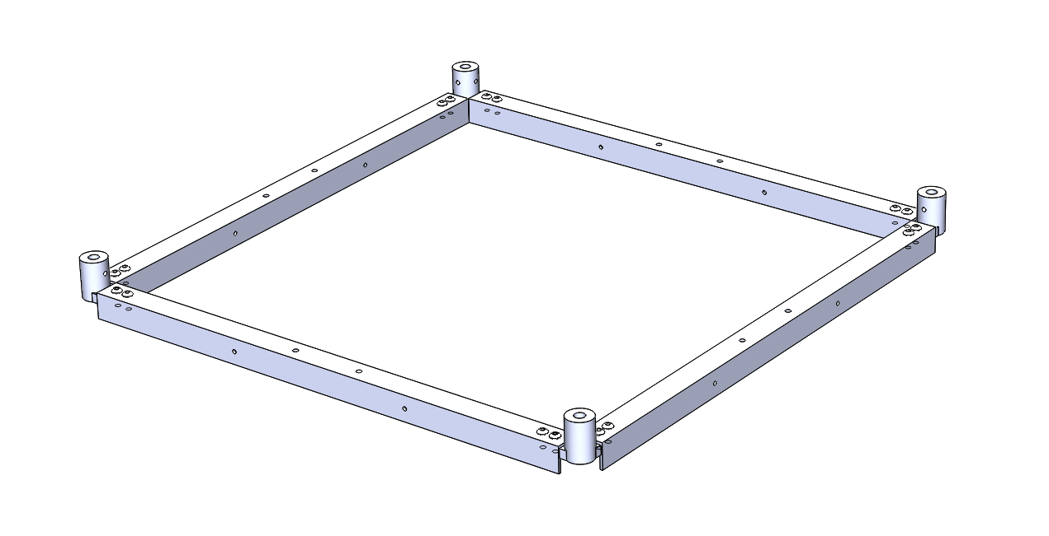

1. Make the base plate as shown in the drawing below from fiberboard 3mm thickness.

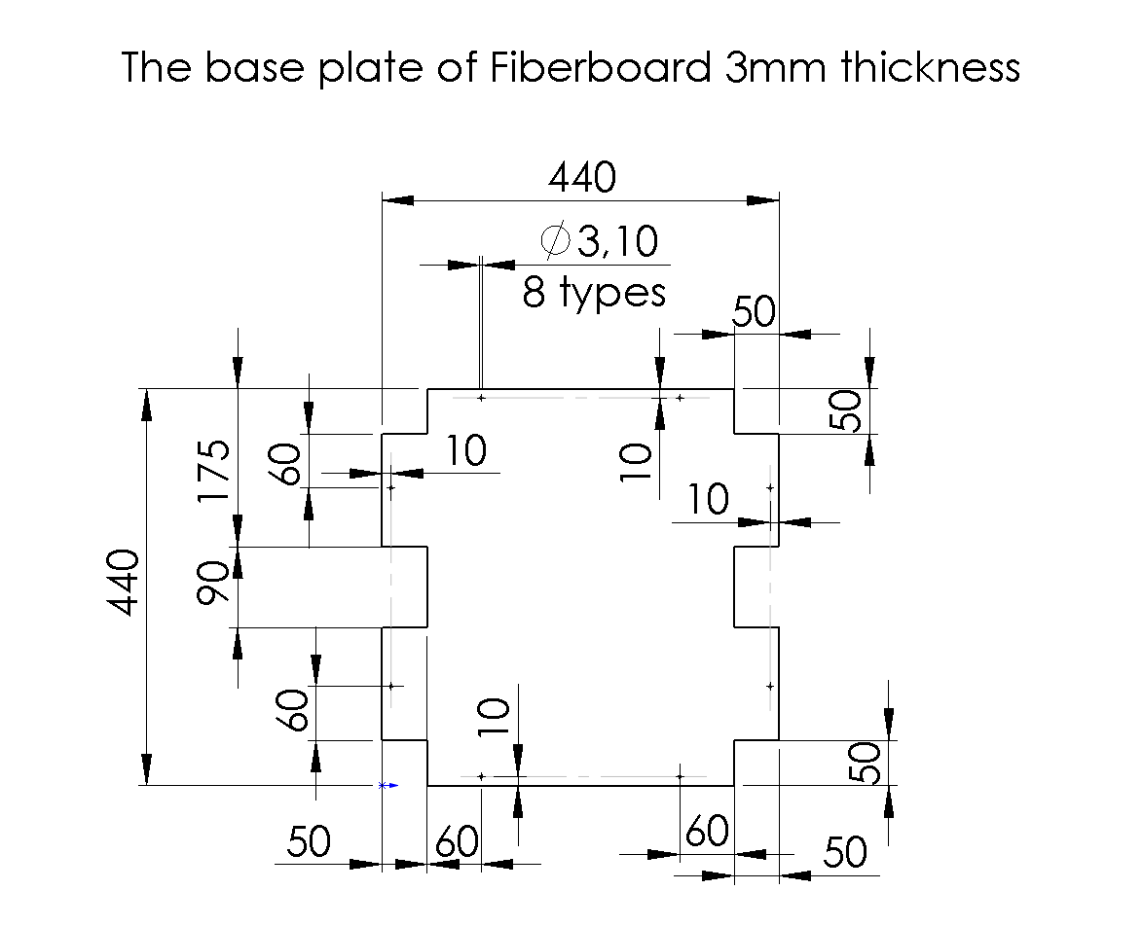

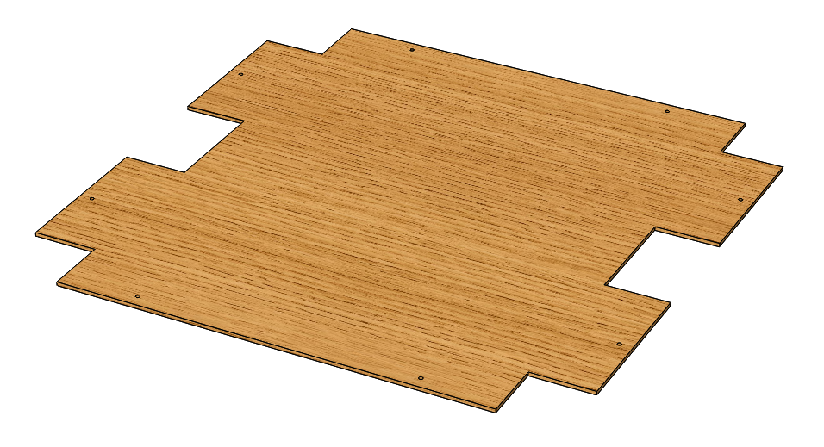

1. Connect the base plate to the low frame as it is shown in the picture below by using M3x12 screws and M3 nuts from the bottom. The holes for the screws in the u-profile shall be made during the assembly.

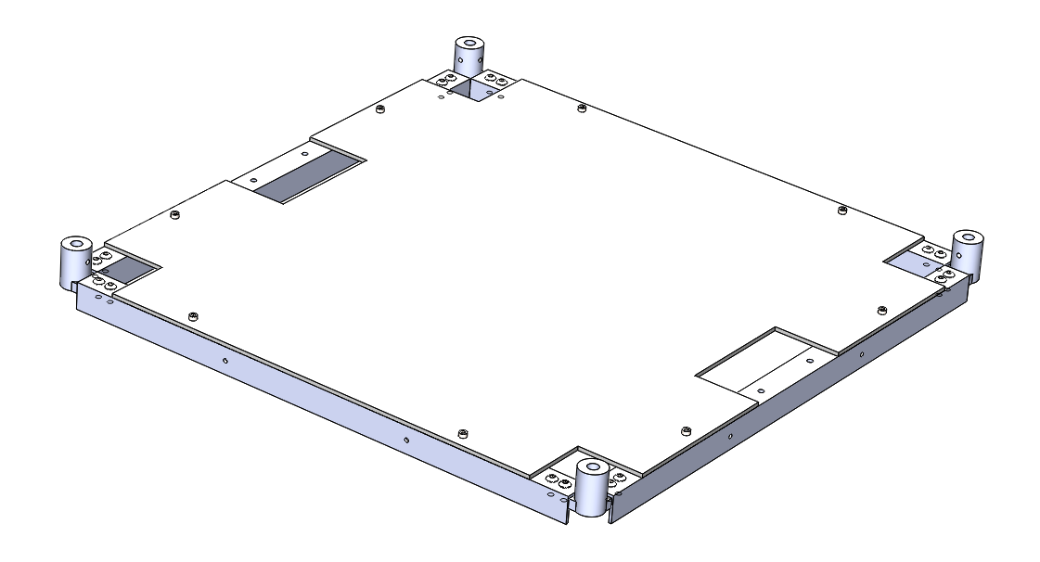



# Upper Frame

1. Print four cornels of the upper frame: Corner LU, Corner LU B, Corner RU F, Corner RU B.
2. Make thread M4 in four holes of each corner.
3. Make thread M3 and M6 in two vertical holes as it is shown in the picture below.

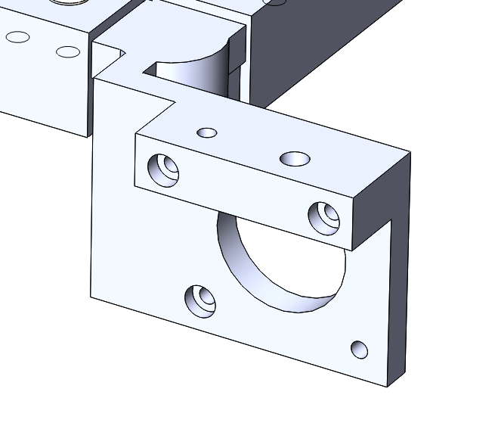

M6

M3

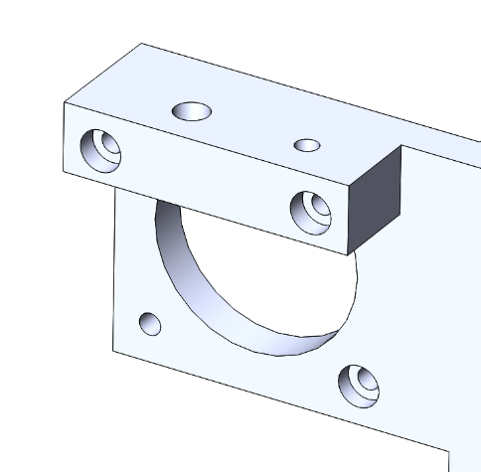

M3

M6

1. Take one profile made according to item 3 of the low frame.
2. Make the left and right side profile for the upper frame according to the drawing

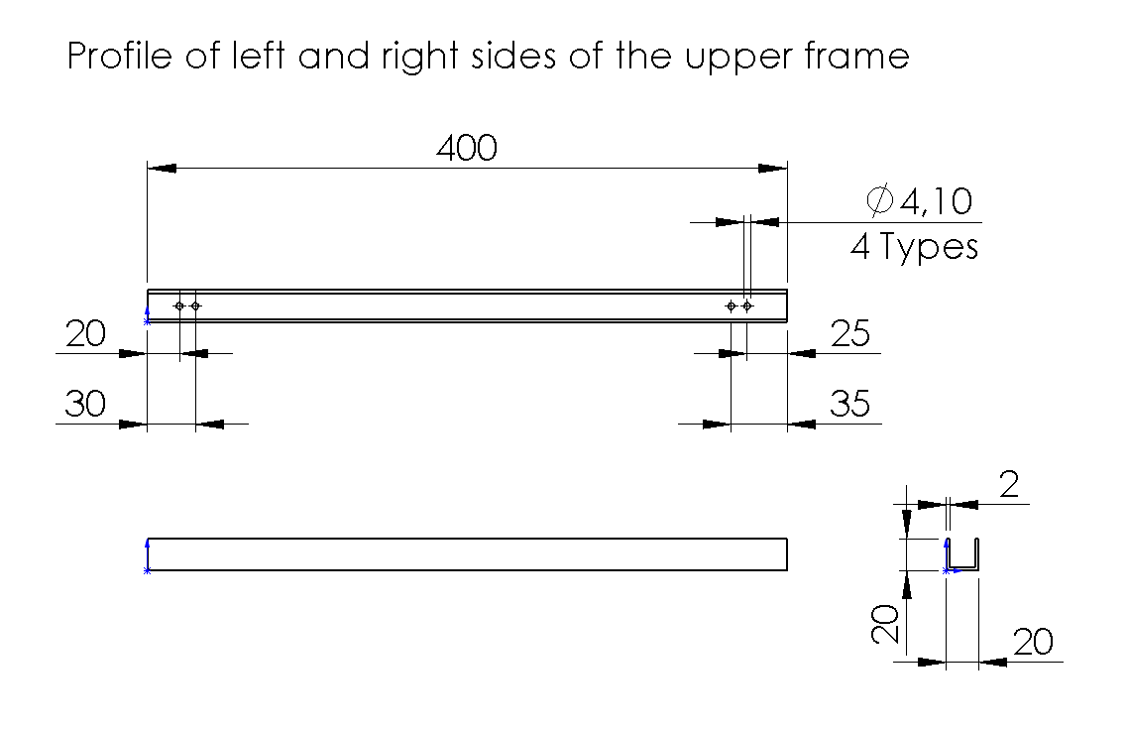

1. Make the back side profile for the upper frame according to the drawing

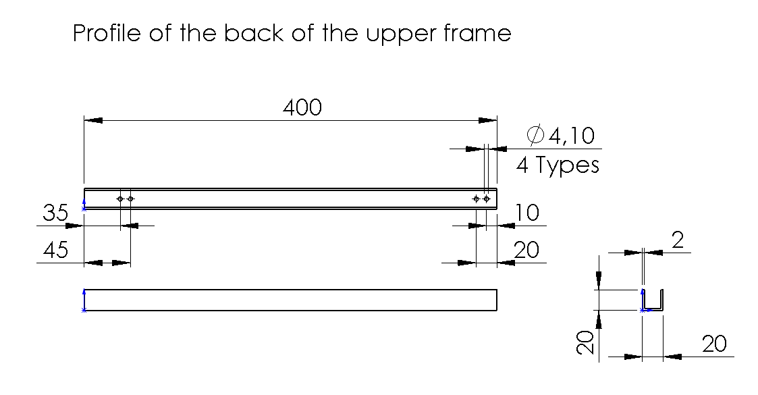

1. Assembly all profiles and corners by using M4x12 socket button head screws as shown in the picture below

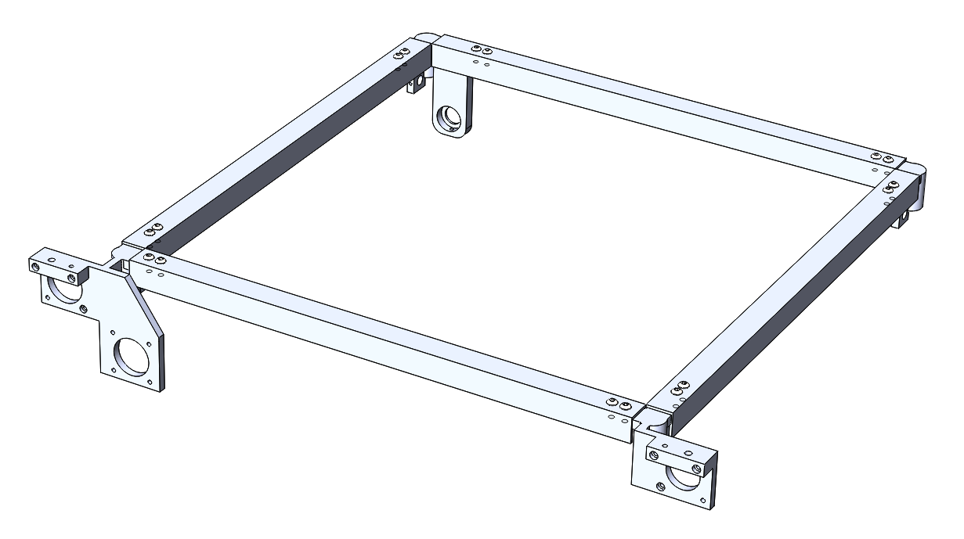



# Hotbed sliding frame

1. Make two profiles for the right and the left sides of the hotbed sliding frame according to the drawing below.

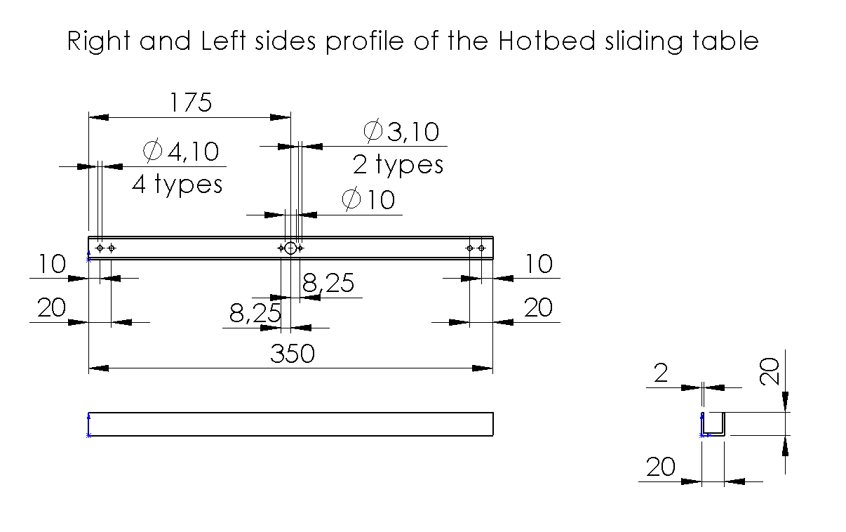

1. Make four profiles for the cross of the hotbed sliding frame according to the drawing below.

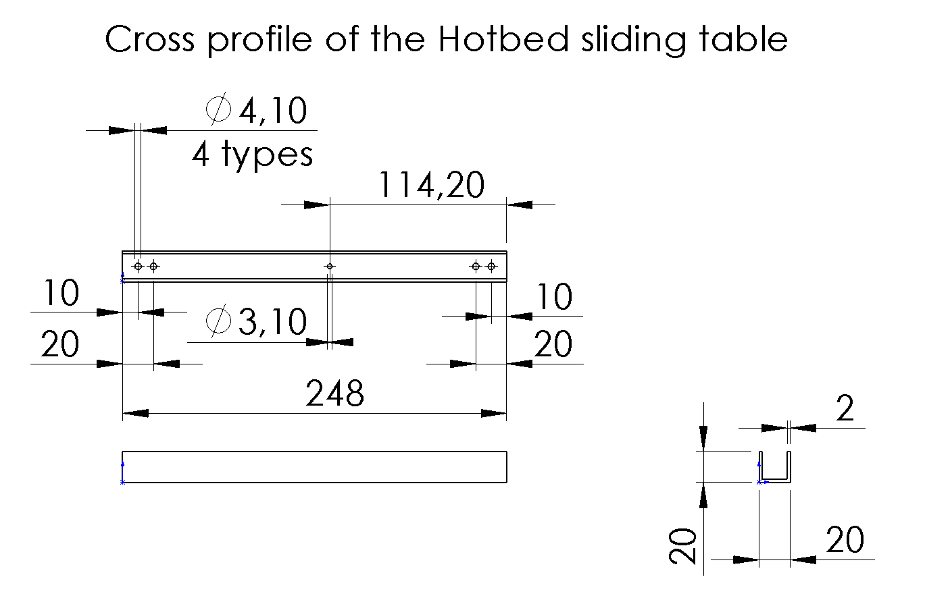

1. Print four units of the Corner B1.
2. Print one unit of the Cross.
3. Make 4M thread in all holes of the plastic parts.
4. Take the nuts of the T8 x 300 Screw and assembly to the side profiles by use M3x12 socket head cap screws as it is shown in the picture below.
5. Assembly the hotbed sliding frame by using M4x12 socket button head screws as it is shown in the picture below.

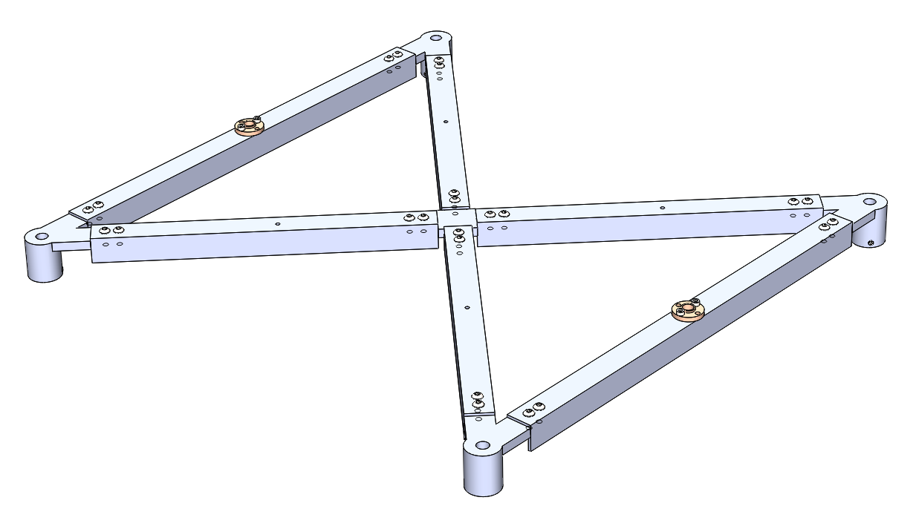

# Cube assembly

1. Putt the axises 400mm long in the low frame

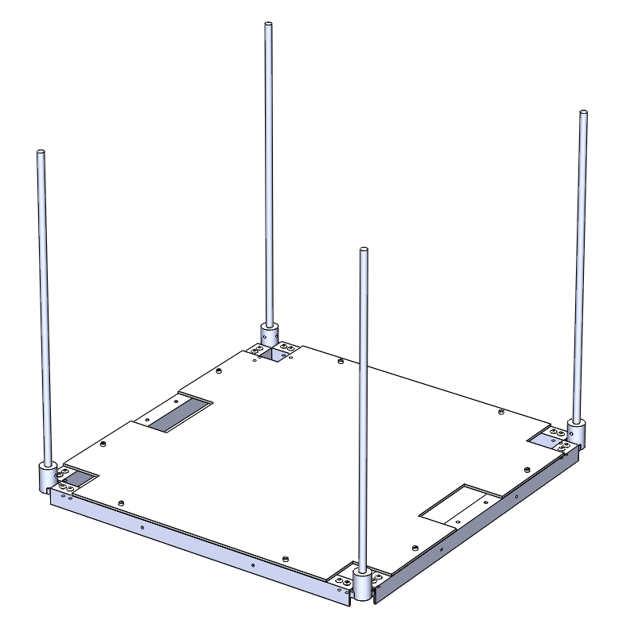

1. Print and assemble two units of Motor Holder 1 with motors 42BYGH34 motor by using the motor’s screws.
2. Preassembled Motor Holders with motor assemble with low frame by using M4x12 socket button head screws.
3. Set a one stop end holder to the right front axis.

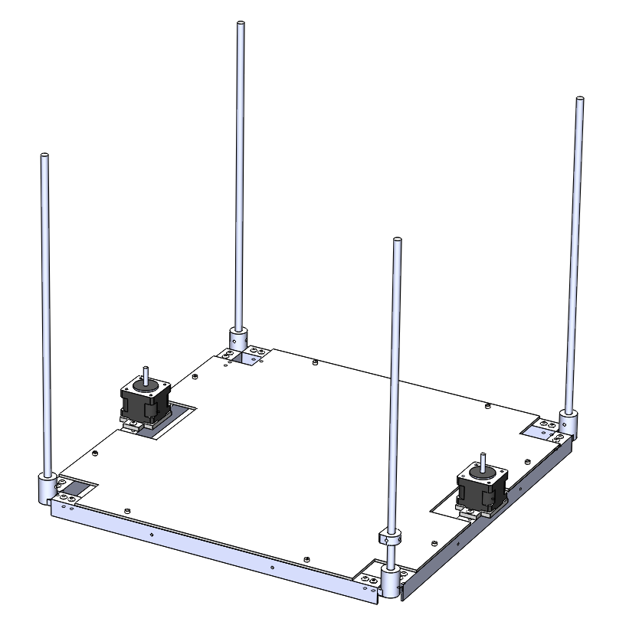

1. Assembly Flexible Shaft Coupling 5 x 8 to the motor shaft and then putt the hotbed sliding frame on the axes.
2. Assemble two T8x300 driving screws to the motors through the flexible shaft couplings and set the hotbed sliding frame on the mean value as it is in the picture below.

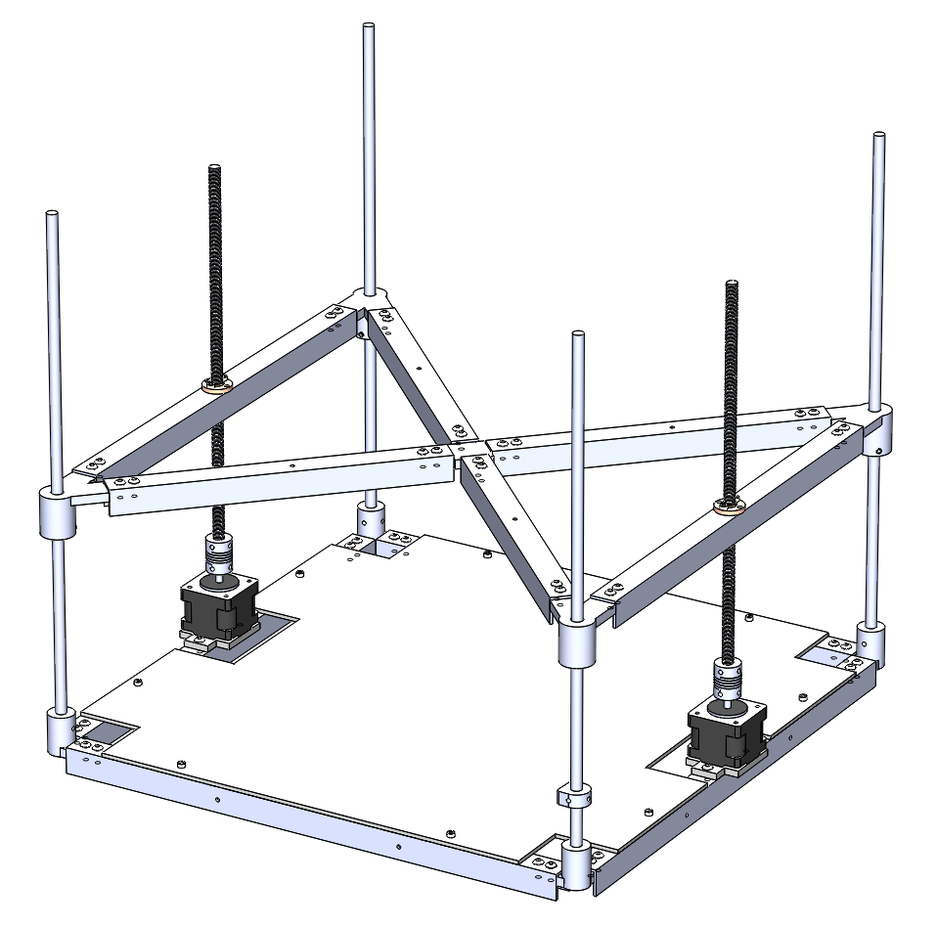

1. Print and set two preassembled Wheel holders with Timing Wheel T16 W6 ID3 OD13 by using Hex M3 x 25mm Socket Cap Screw, two M3 nuts, and two washers on the right side axes.

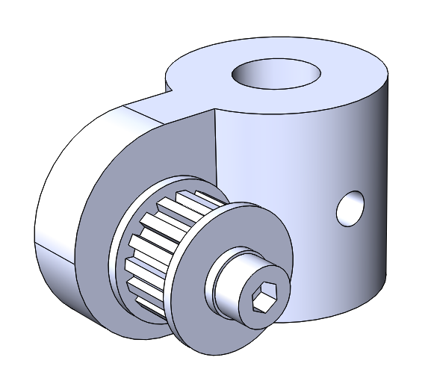 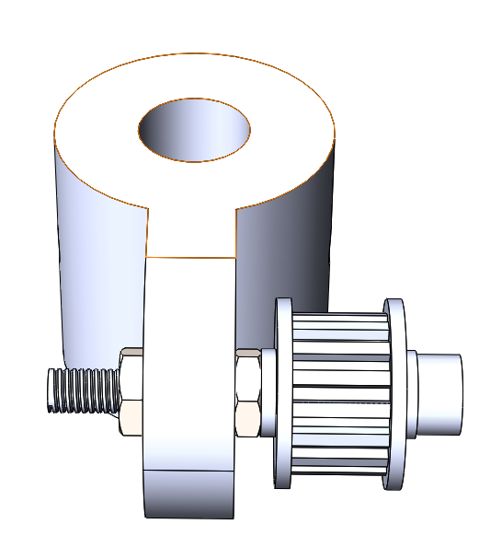

1. Set a one stop end holder to the right front axis.
2. Assembly the Upper Frame.

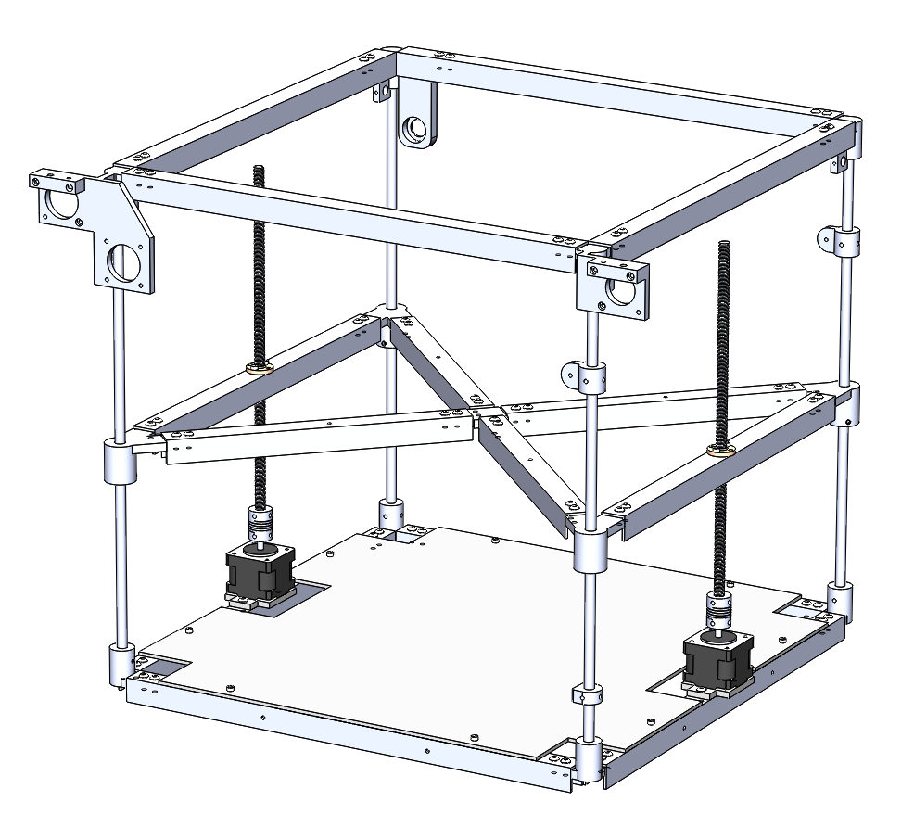

*Note:* All plastic corners should be closed on the vertical axes by socket set cone point M4 x 6mm screws.

The end stop holder and wheel holders should be closed on the vertical axes by socket set M3 x 6mm cone point screws.

# X-Axis

1. Putt the bearing 636zz into the bearing holder of Corner LU B and close it by socket set M3 x 6mm cone point screw.
2. Assembly the motor 42BYGH40 or similar by using socket head cap screw M3 x 8mm.
3. Assembly the Shaft Coupling 5 x 6 to the motor shaft.
4. Assembly the Linear axis 450 x 6 with two Timing Wheel T16 W6 ID6 OD13 and connect to the motor.

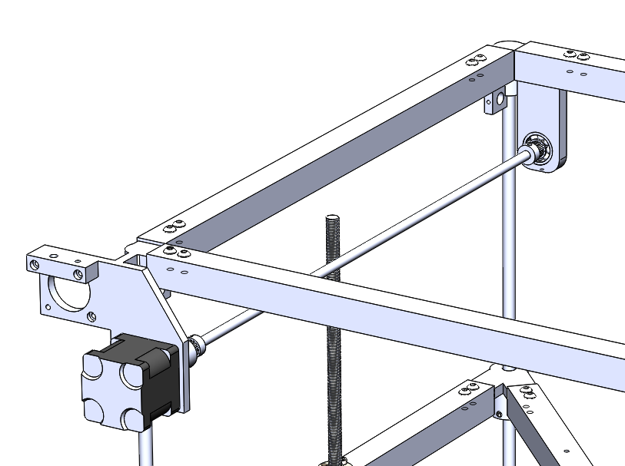

1. Print the Front Train and preassembly it with two Timing belt holders by using four socket head cap screws M3 x 12mm for each one.
2. Connect one Timing Wheel T16 W6 ID3 OD13 by using one socket head cap screw M3 x 20mm.
3. Putt two linear bearings LM8SUU and close them by two socket set screws M3 x 6mm cone point.

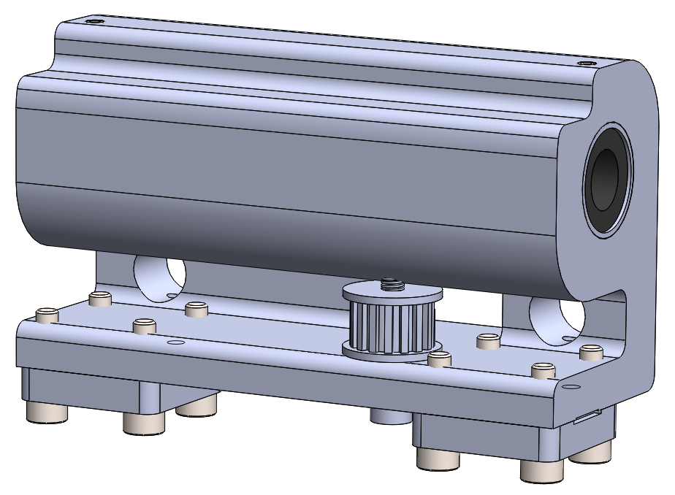

1. Print the Back Train and preassembly it with two Timing belt holders by using four socket head cap screws M3 x 12mm for each one.
2. Putt two linear bearings LM8SUU and close them by two socket set screws M3 x 6mm cone point.
3. Assembly the motor 42BYGH40 or similar by using socket head cap screw M3 x 8mm.
4. Connect the Timing Wheel T16 W6 ID5 OD13 to the motor shaft.

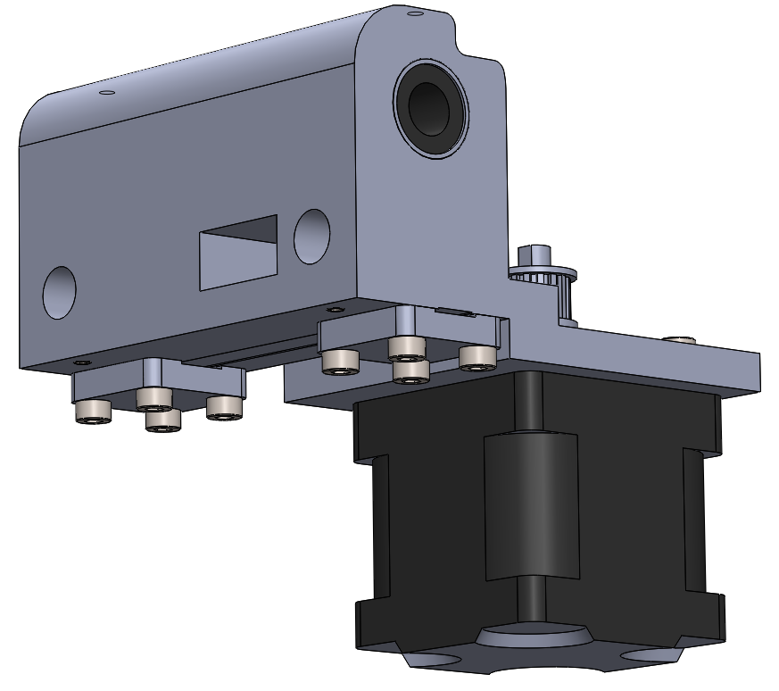 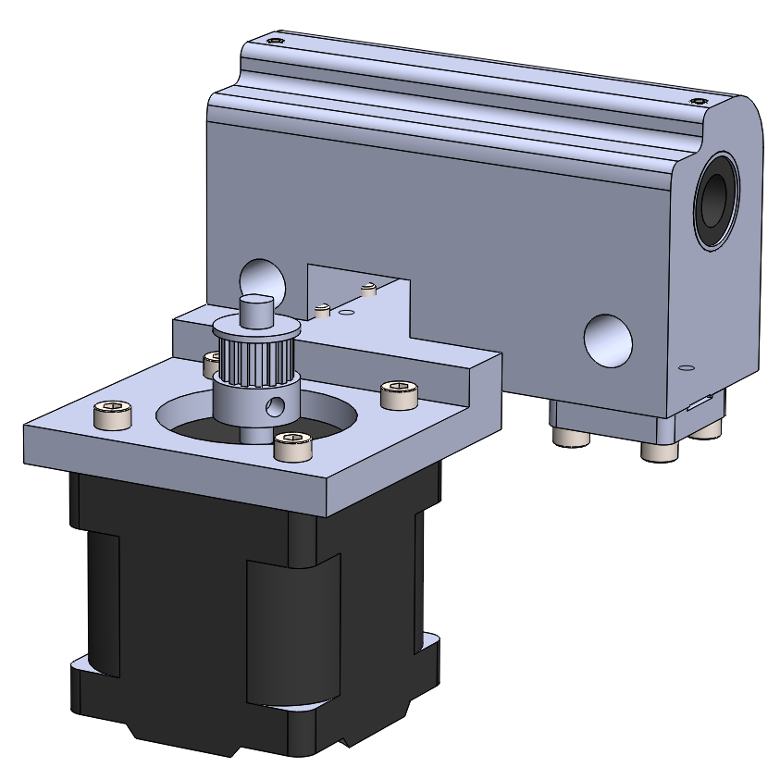

1. Putt two Linear axes 450 x 8 as shown in the picture below.
2. Assembly preassembled Front Train and the Back Train.
3. Add two Stop End Holders to the back axis.

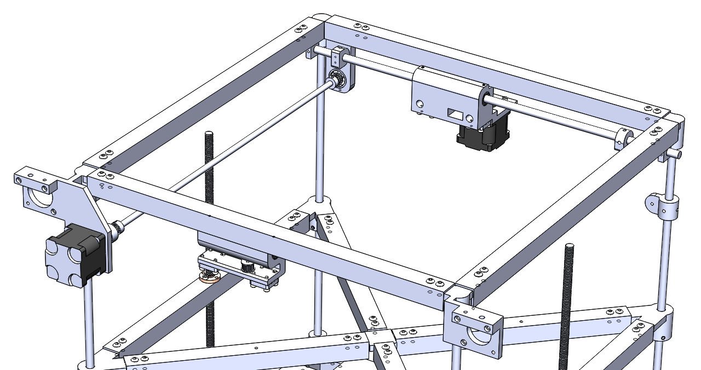

1. Set the Timing belt GT2 W6.

# Y-Axis

1. Print the Y Train plastic part and the Extruder holder.
2. Putt two linear bearings LM8SUU and close them by one socket set screws M3 x 6mm cone point.
3. Assembly the V6 Dual Nozzle 2 In 2 Out Double Head with 3010 Fun.

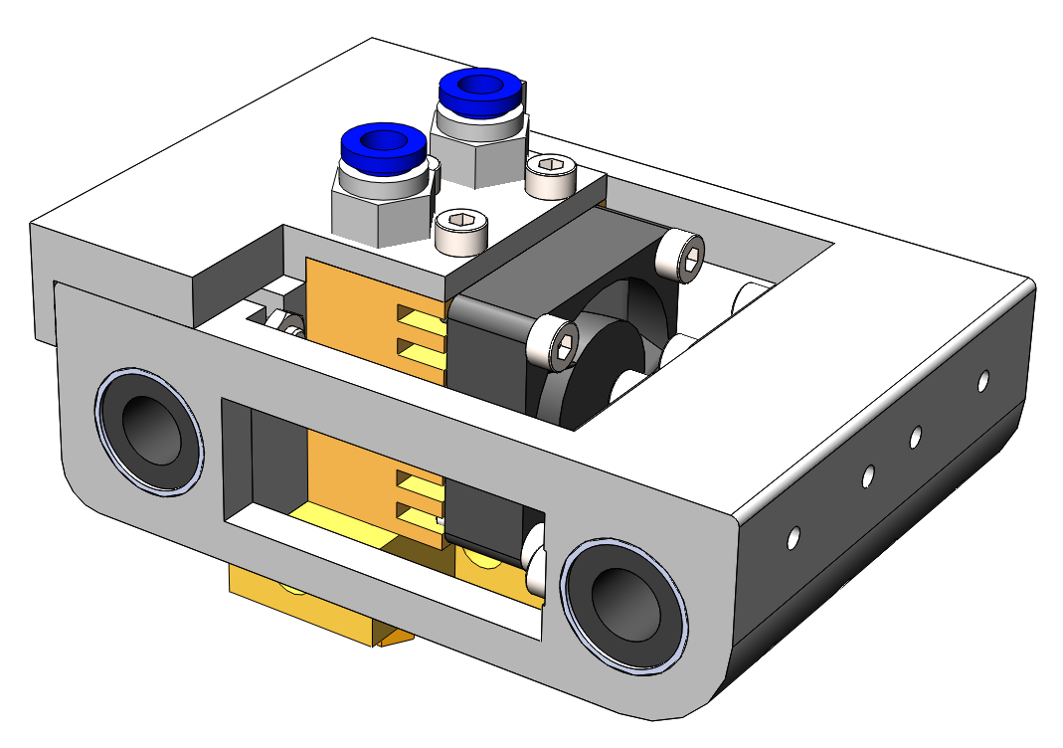

1. Assembly the preassembled Y-train to the printer by using two axes 8mmx450mm as it shown in the picture below.

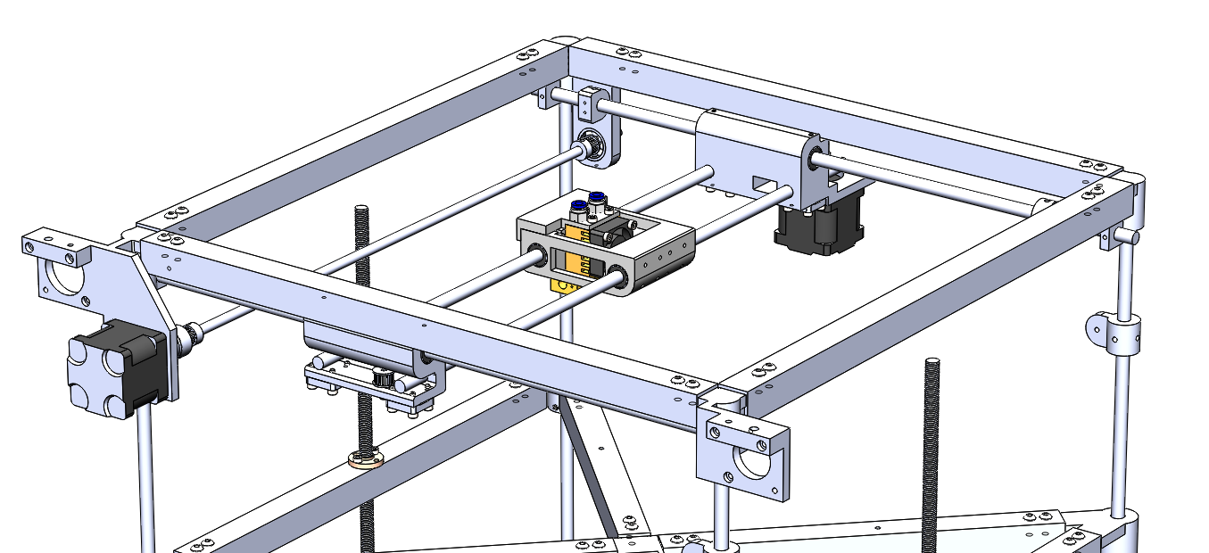

1. Set the Timing belt GT2 W6.

# Hotbed

1. Assembly the standard aluminium 3mm thickness Hotbed as it shown in the picture below.

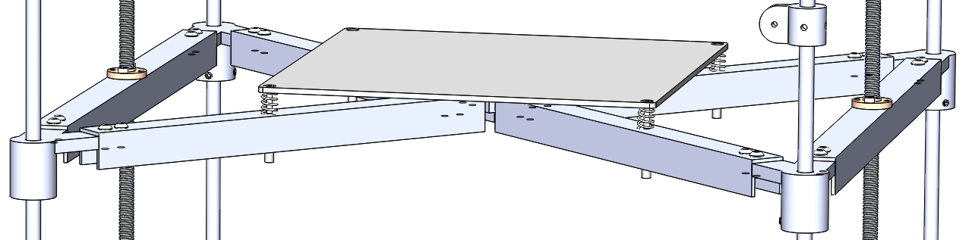

Use for this four socket countersunk head screws M3 x 30mm, Steel Springs 8mm OD, wires 0.8mm, and 20mm length, and the Long Nuts M3 x 30mm.

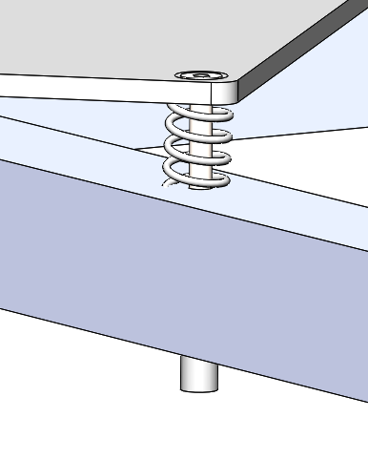

# Feeders

1. Assembly two 42BYGH48 motors by tow upper Socket head cap screws M3 x 12mm and one Socket head cap screw M3 x 8mm.
2. Putt the 26 Tooth Motor Shaft 5mm Gear Wheel on each motor.

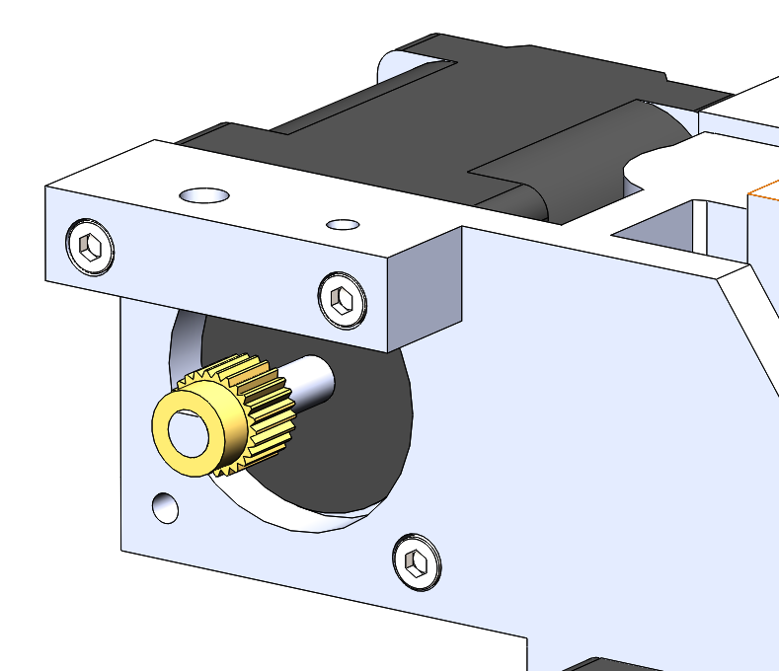

1. Assembly Extruder Flap with preassembled Guide Wheel Pulley Bearing U604ZZ 4x13x4mm to each feader by Hex M3 x 25mm Socket Cap Screw.

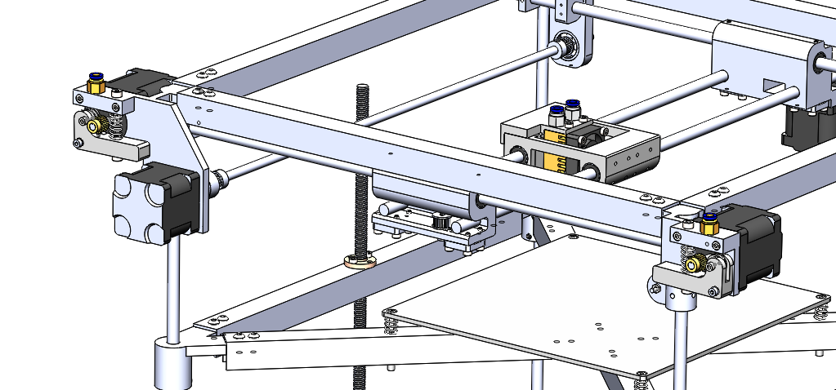

1. Assembly Fitting for filament PC4-M6 OD 4mm ID 2mm.
2. Assemble Hex M3 x 20mm Socket Cap Screw from the upper and socket head cap screw M4 x 16mm from the bottom and putt between tyhem the Spring 8mm x 25mm.

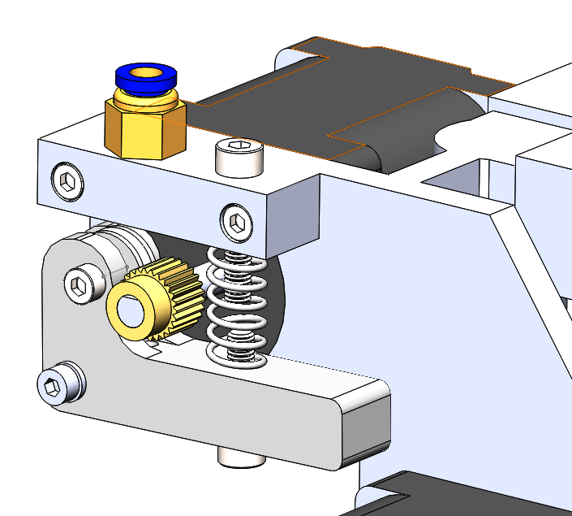

# Power supply & Main Board with control screen

1. Assembly the power supply close to the back and right sides and screw by appropriate screws to the base plate.
2. Assembly the Power Supply Holder close to the back side. Putt there the 15A 250V IEC320 C14 3 Pin Fused Power Socket Connector Rocker Switch and close it by Power Supply Holder cap.
3. Connect the 15A 250V IEC320 C14 3 Pin Fused Power Socket to the power supply.

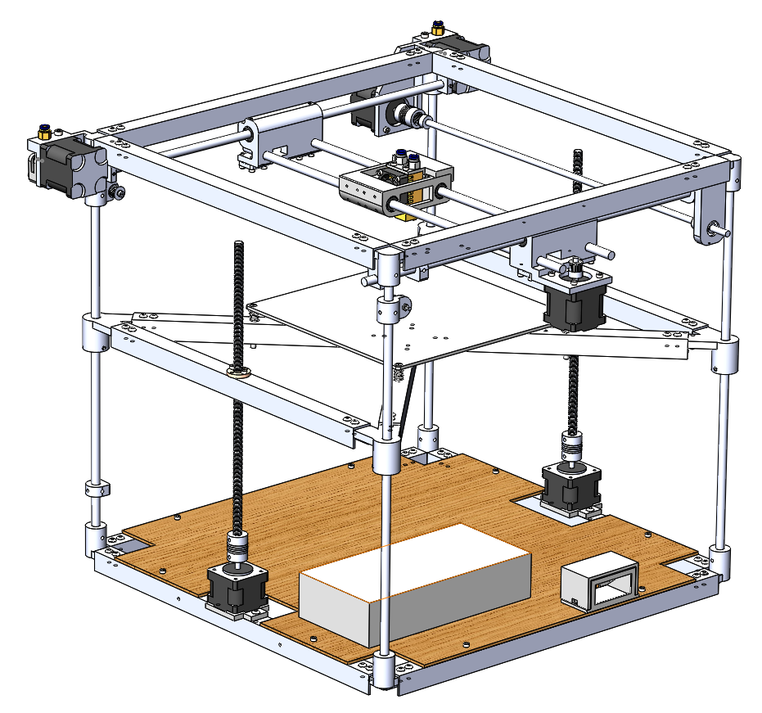

1. Putt the main board at approximately center of the base plate.

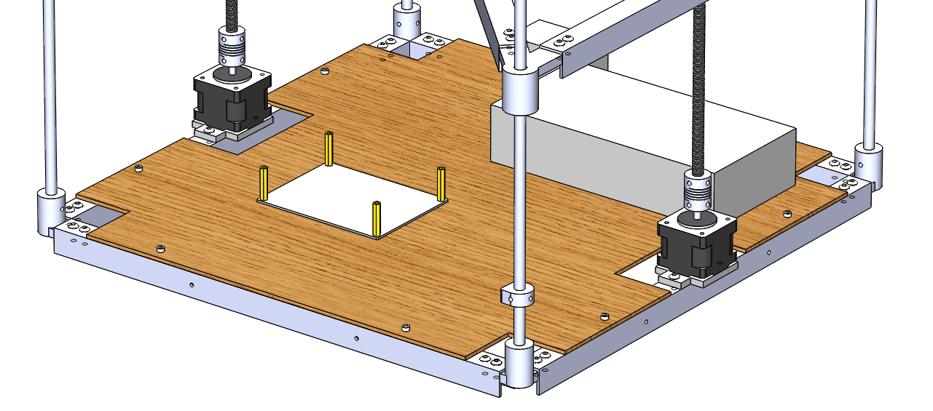

1. Connect all electrical components and then close the Cap MkB.

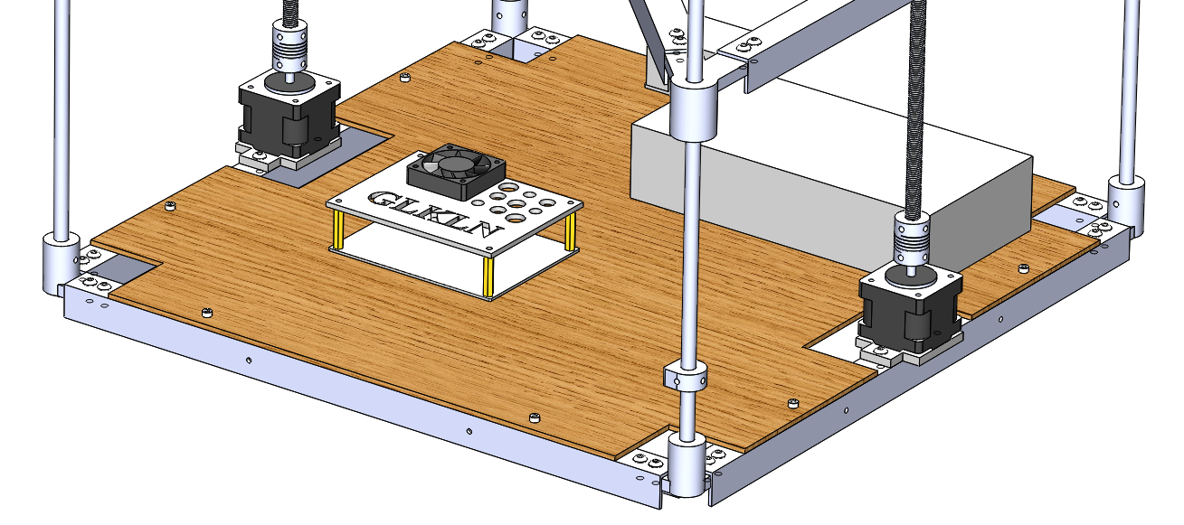

1. Preassembly the Front panel with LCD 2004 screen by Hex M3 x 20mm Socket Cap Screw .

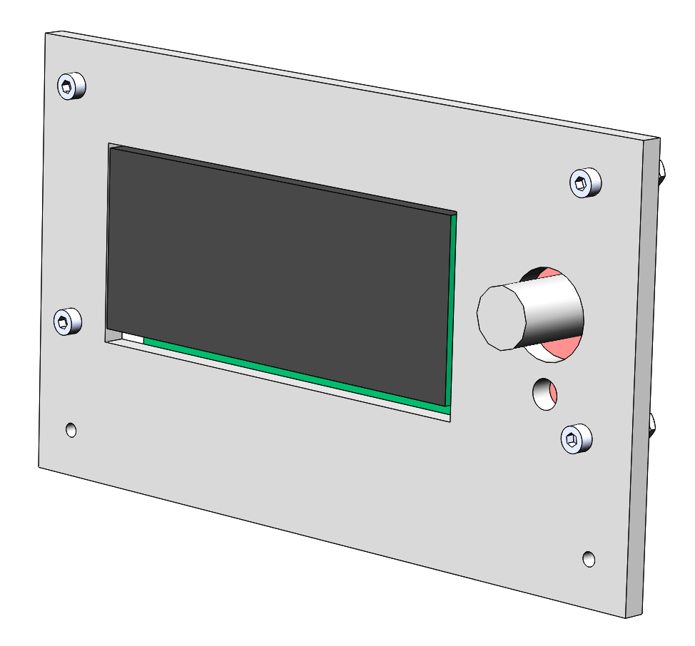 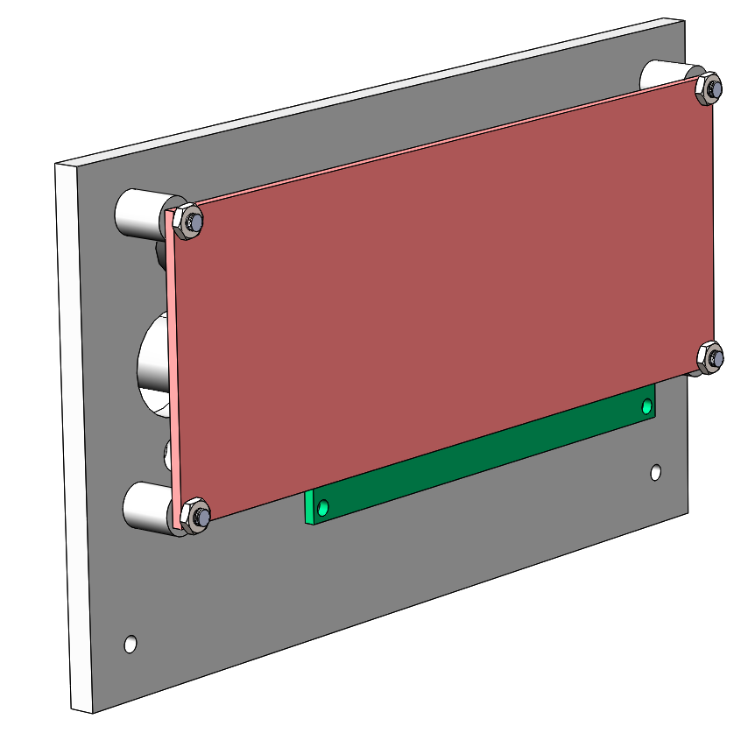

1. Connect this fron panel with screen to the front lower profile at midle.

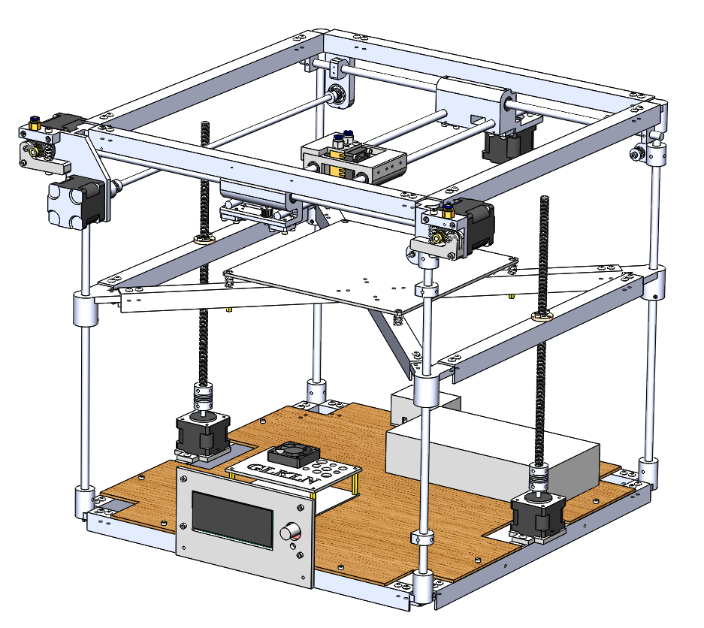

# Side panels

1. Three preassembled side panels assembly at the midle of the right, the left, and the front sides.

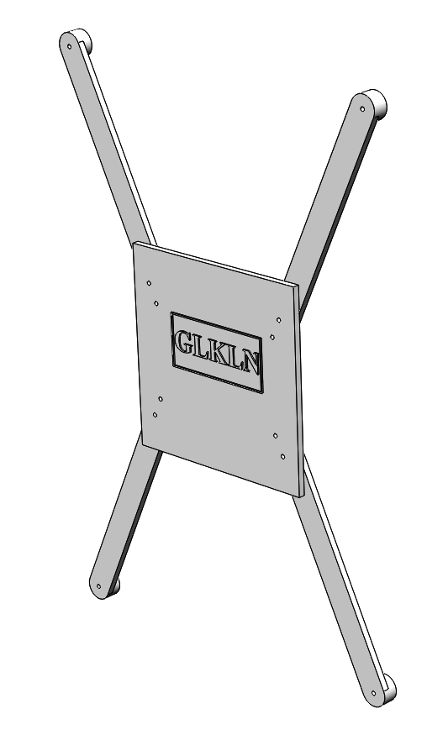 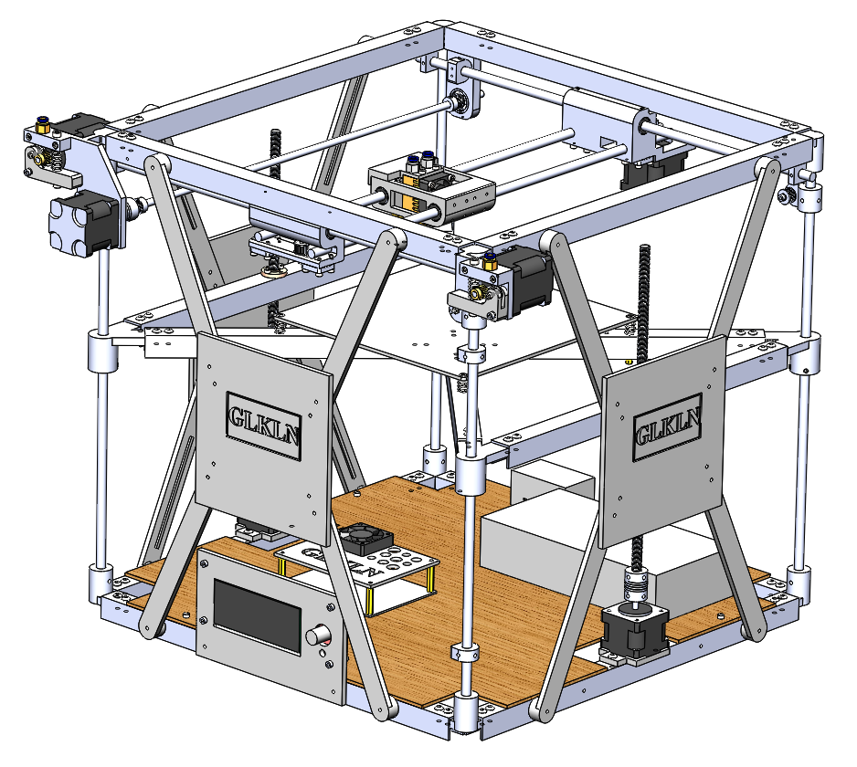

1. The preassembled back panel assemble at the back side of the printer.

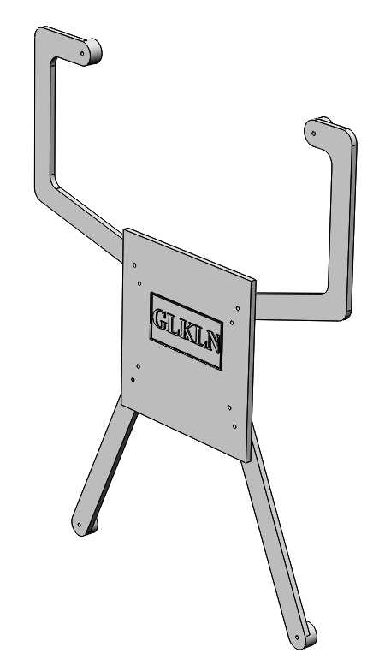 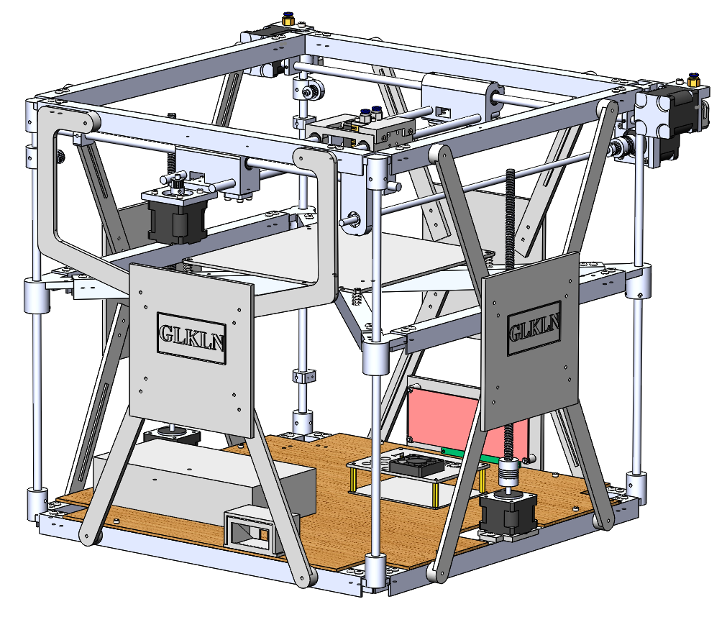

# Final steps

Need to connect all electrical components to the MKS or other mother board. Appload the software that you can get from the Firmware folder, and then the printer is ready to work.

Before the first print calibrate the hotbed by procedure through the control screen or through the hosting program.

Recommend to use RepetierHost SW to menage the printer through PC.

# Videos

<https://www.youtube.com/watch?v=GEYLdS9rxzs>

<https://www.youtube.com/watch?v=eaGODYXviRs>